**What is React Js?**

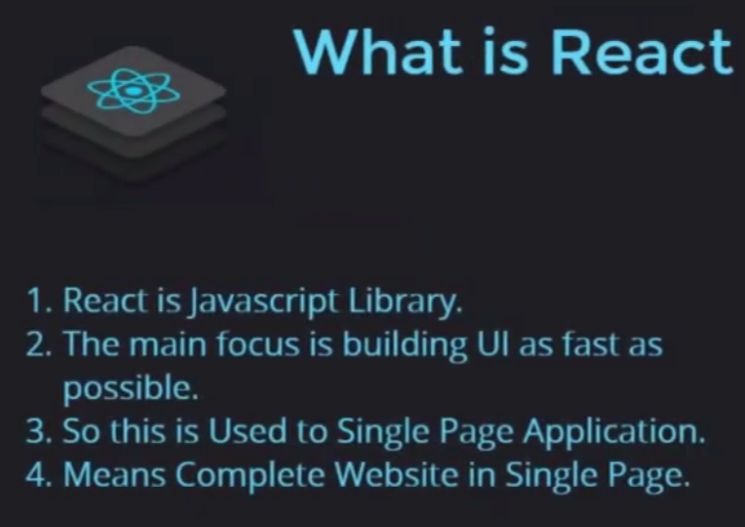

The entire component gets loaded in the first execution and then whenever we click on any link then it does not reload the page again and again and hence it becomes faster.

**Why React is Fast?**

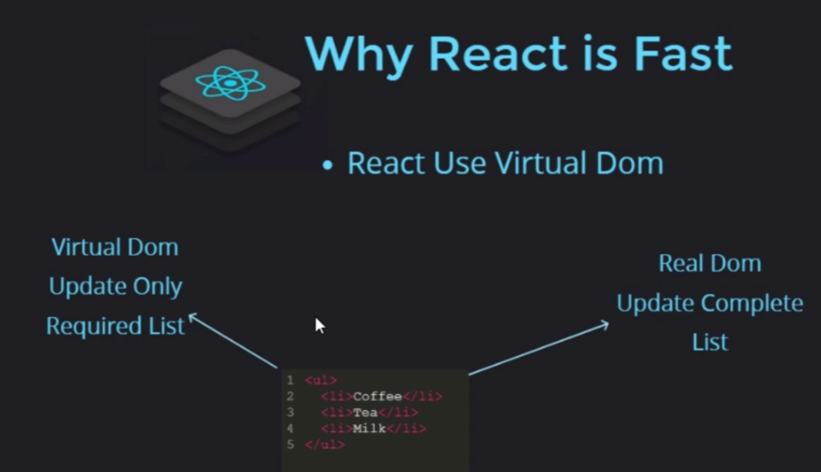

1. React uses the virtual Dom that is why it faster than angular js or other JS.
2. For example let’s say here we have one list having three items. Now if we try to add new item or want to modify any existing item then in case of AJ or other JS whole list will be impacted and whole list will be reloaded to reflect the changes and thus it takes time, but in case of RJ if we want to add new list or want to modify any list then it does impact on that particular list item only and does not require to reload the whole list to get latest changes.



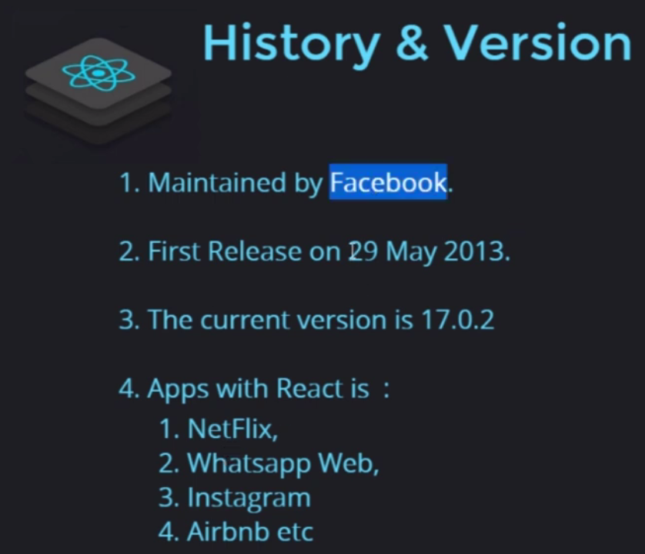

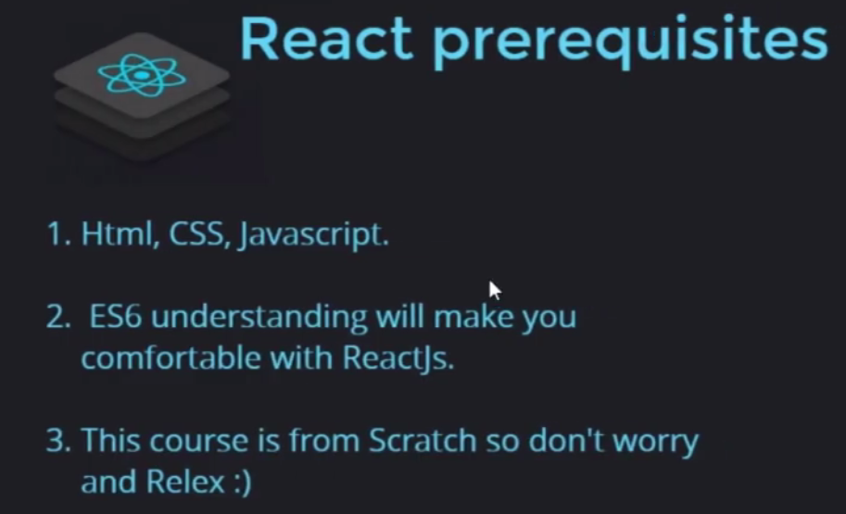

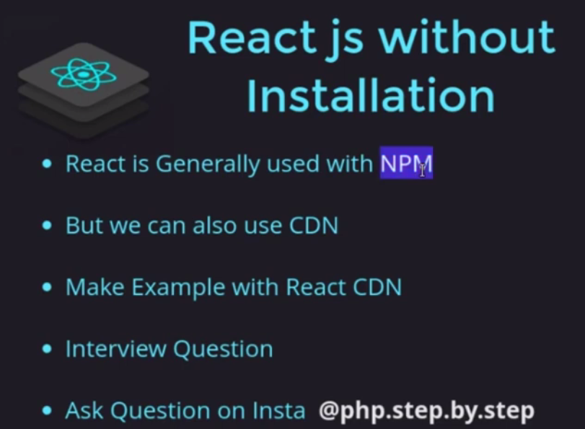

**Let’s create our first react application with CDN**

1. Go to the folder where we have to keep all the files
2. Type code. (dot) and it will open your visual studio
3. Here instead of installing node js first of all we will try to run react using CDN link

|  |
| --- |
| **<script crossorigin src="https://unpkg.com/react@17/umd/react.production.min.js"></script>**  **<script crossorigin src="https://unpkg.com/react-dom@17/umd/react-dom.production.min.js"></script>**  **<script crossorigin src="https://unpkg.com/babel-standalone@6.15.0/babel.min.js"></script>** |

1. First link is for react, second link is for dom and third link is for babel

**Example 1- Index.html:**

|  |  |
| --- | --- |
| <htm>      <head>          <script crossorigin src="https://unpkg.com/react@17/umd/react.production.min.js"></script>          <script crossorigin src="https://unpkg.com/react-dom@17/umd/react-dom.production.min.js"></script>          <script crossorigin src="https://unpkg.com/babel-standalone@6.15.0/babel.min.js"></script>      </head>      <body>          <div id="mydiv">              Hello REact          </div>          <!--Write a React Js code insde script-->          <script type="text/babel">              class Hello extends React.Component{                  render(){                      return <div>Hello React With code </div>                  }              }              // Now connect this class Hello with div id mydiv              ReactDOM.render(<Hello />,document.getElementById('mydiv'))          </script>      </body>  </htm>  So Here in the above example:   1. Added the React JS CDN link inside the header 2. Written the React JS code inside <script type=”text/babel”></script> 3. Created one class Hello and extends class Component class of React[React.Component] 4. Here to display the react js code we have used **render** () {….} 5. Finally we have to connect the HTML div to react js code and for that we will use ReactDOM.render(<className,id)   ReactDOM.render(<Hello />,document.getElementById('mydiv'))  Here we have passed the class name in the form of html tag <Hello /> and html div id. In this way we can connect html to react js.  So the above example we have written with the help of the help of CDN path  **Example2:**  Let’s add one component or function and add one button which displays one popup on click on button.  <htm>      <head>          <script crossorigin src="https://unpkg.com/react@17/umd/react.production.min.js"></script>          <script crossorigin src="https://unpkg.com/react-dom@17/umd/react-dom.production.min.js"></script>          <script crossorigin src="https://unpkg.com/babel-standalone@6.15.0/babel.min.js"></script>      </head>      <bod>          <div id="mydiv">              Hello REact          </div>          <!--Write a React Js code inside script-->          <script type="text/babel">          function Test(){                  const myButton=()=> alert("Test is called") // Create a function myButton                  return <button onClick={myButton} >Click me</button>              }     // To link this Test() method of function with the Hello class , we just need to inclue like <Test /> in the render()! shown above              class Hello extends React.Component{                  render(){                      return <div>Hello React With code <Test /></div>                  }              }              // Create one more function or component and call inside Hello class                // Now connect this class with div id mydiv              ReactDOM.render(<Hello />,document.getElementById('mydiv'))  // It takes two parameter 1- class name 2- mydiv id          </script>      </body>  </htm>  So we can add any component or function just like an Html tag. | |
|  |  |

In the above example:

1. Created on function Test and inside this function written the logic to popup alert message on button click event
2. Here inside the Test() function we have created one more function myButton() which implements the alert message and this myButton() is being called on OnClick event
3. After that we are calling this function Test() with the class Hello just by using html tag <Test />

So in the above two examples we have created React Js class and function just by including React JS script tag from CDN path. Now we let’s setup the React Js environment in the next.

**Note**: Whenever any error occurs in the React JS application then we can see it in the HTML console just by clicking F12 button.

***Note***: whether we create any function or class in the React JS, it is called component normally.

**Environment Setup**



1. **Installing NPM.**

Now to check whether it is installed or not we have to check two commands- as given below.

|  |  |
| --- | --- |
| E:\ReactJs>node -v  v14.17.0 | E:\ReactJs>npm -v  6.14.13 |

1. Now create folder where we want to create our own react js project

**Note**: When we install node js then at the same time along with npm one more component **npx** is also gets installed, which we will use in creating the new react js application using command line as given below.

1. **Let’s create react js application using npx component as shown below.**

|  |  |
| --- | --- |
| 1. ***npx create-react-app* [ApplicationName]** |  |

**So as soon as we click enter we start getting the below status for creating new application depending upon internet speed.**

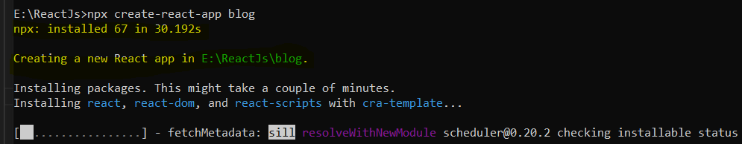

**Note:** So here **npx** is installed and further creating react app. During project creation it will install other component like react, react-dom, react-script, cra-template required for react application.

|  |  |
| --- | --- |
|  | Once we give code . (dot) it will directly open with the project structure. |

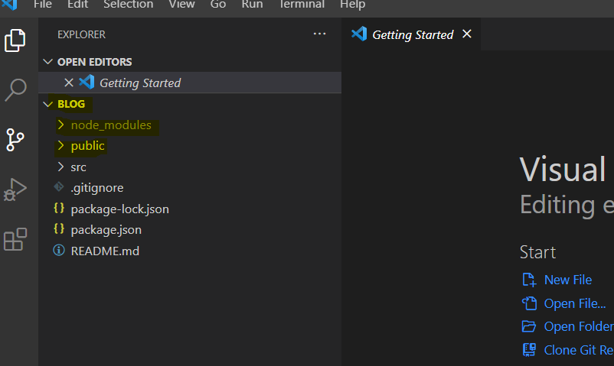

Now let’s start the npm using command npm start

|  |  |
| --- | --- |
|  | <http://localhost:3000> |

**Q- AS here we can see that we can run the react application by using CDN then why we use NPM?**

**NPM** – stands for Node package manager, so it manages all the packages required for the node and it manages all the required packages inside **node_modules** of the project. Now let’s say if we want to include external package (or libraries) for other functionality like Google map etc then in that case NPM plays very important role. We just need to mention the package-name on the cmd [npm install package-name]



Now the NPM will install the same package inside the **node_modules** of the project automatically and we don’t need to mention the path for this package while accesses this package functionality in the project, NPM will take care all the things.

Another things it minifies the code during project build for production deployment version, and hence project size gets reduced and all the codes converted into one file and in this way our application becomes more faster and secure also.

Q- What is the alternative of NPM?

**Yarn Package Manager** is the alternative of NPM and this is created and developed by facebook itself.

YPM and NPM almost same and react js app structure will be same wherther we use NPM or YPM

**Creating new file and creating first code in the React Js:**

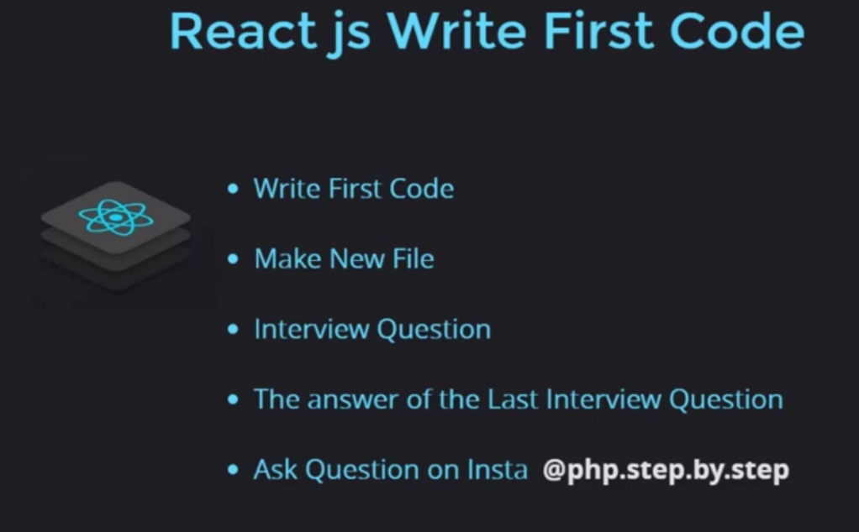

Initially two file from the project is very important to start coding.

1. **Index.js**
2. **App.js**

|  |  |
| --- | --- |
|  | |
|  | This App.js contains one function **App ()** which contains html tag and css tags. If we compare this code content with html page created after hitting (<http://localhost:3000> )  App-logo  Edit src/App.js and save to reload  Learn React  The above things are coming from the App.js only so now Let’s delete this code and just try to create our own content inside the <div> tag. |
| import logo from './logo.svg';  import './App.css';  function App() {    return (      <div className="App">       Welcome to my first React JS code      </div>    );  }  export default App; | So now instead of default display we can see our own displayed code. |

So this is about App.js, now let’s talk about index.js.

|  |  |
| --- | --- |
| **Index.js:**  React Application start its execution from this file  import React from 'react';  import ReactDOM from 'react-dom';  import './index.css';  import App from './App';  import reportWebVitals from './reportWebVitals';  ReactDOM.render(    <React.StrictMode>  **<App />**    </React.StrictMode>,    document.getElementById('root')  );  // If you want to start measuring performance in your app, pass a function  // to log results (for example: reportWebVitals(console.log))  // or send to an analytics endpoint. Learn more: https://bit.ly/CRA-vitals  reportWebVitals(); | This index.js plays very important role because this is the file which loads at the first from the react js application. And the App.js is being called from this index.js file only  **So here we are importing App (). So execution will be**  **Index.js > App.js** |

**So this about App.js and index.js.**

Now let’s create our own first component in the react js application.

Steps

1. Create one file Users.js inside src folder. (right click and create file and put Users.js)
2. Create a function with the same name as the file name contains.
3. Import this Users.js inside the index.js exactly same as App.js is imported
4. Include this <Users /> tag inside the render() method of the index.js

|  |  |
| --- | --- |
| **Users.js**  function Users() {      return (        <div className="App">       <h1> Hello Users from Users function </h1>        </div>      );    }    export default Users; | **Index.js**  **import React from 'react';**  **import ReactDOM from 'react-dom';**  **import './index.css';**  **import App from './App';**  **import Users from './Users';**  **import reportWebVitals from './reportWebVitals';**  **ReactDOM.render(**  **<React.StrictMode>**  **<App />**  **<Users />**  **</React.StrictMode>,**  **document.getElementById('root')**  **);**  **reportWebVitals();** |

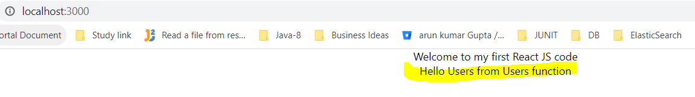

So in this way we can create our own file and include in the index.js

**Q**- How to check the react current version from the project?

**A**- We can see it from **package.json**

**Understanding the React Js Application file and folder structure**

|  |  |
| --- | --- |
|  |  |

As we have seen that

**Package.json**: This is most important file for react js application it contains several information as listed below.

1. Application name and its version
2. Commands to start, build, test and eject the application
3. React current version being used in the application
4. All the dependent libraries

**Package-lock.json:**

1. It contains the detail of package.json
2. It also contains application name and its version
3. It contains the detail and history of the packages used in the application and controlling their versioning also
4. For example we have used **babel** **CDN** and here we can see that it contains the complete detail of the packages like its version, location (resolved) and integrity (it is nothing but the hashCode)
5. It contains the detail of child package dependencies also.e.g. if we see then **babel** is dependent on code-frame, generators, helpers etc

So in short we can say that package.json contains application detail and package-lock.json contains the detail of package.json as well as the it contains the detail of all the packages or library (present inside node_module folder), its child packages, history, and unique code for each package

|  |  |
| --- | --- |
| **Package.json:**  {    "name": "blog",    "version": "0.1.0",    "private": true,    "dependencies": {      "@testing-library/jest-dom": "^5.14.1",      "@testing-library/react": "^11.2.7",      "@testing-library/user-event": "^12.8.3",      "react": "^17.0.2",      "react-dom": "^17.0.2",      "react-scripts": "4.0.3",      "web-vitals": "^1.1.2"    },    "scripts": {      "start": "react-scripts start",      "build": "react-scripts build",      "test": "react-scripts test",      "eject": "react-scripts eject"    },    "eslintConfig": {      "extends": [        "react-app",        "react-app/jest"      ]    },    "browserslist": {      "production": [        ">0.2%",        "not dead",        "not op_mini all"      ],      "development": [        "last 1 chrome version",        "last 1 firefox version",        "last 1 safari version"      ]    }} | **Package-lock.json**  {    "name": "blog",    "version": "0.1.0",    "lockfileVersion": 1,    "requires": true,    "dependencies": {      "@babel/code-frame": {        "version": "7.14.5",        "resolved": "https://registry.npmjs.org/@babel/code-frame/-/code-frame-7.14.5.tgz",        "integrity": "sha512CgFkbaqeOM+vOtCS5ndmJicPJhKAwYRI6UfFw==",        "requires": {          "@babel/highlight": "^7.14.5"        }      },      "@babel/compat-data": {        "version": "7.15.0",        "resolved": "https://registry.npmjs.org/@babel/compat-data/-/compat-data-7.15.0.tgz",        "integrity": "sha512IJE0S0+lL1SWFMxMkz1pY+sno5m3yH9BDsnXkpxiA=="      },  "requires": {          "@babel/code-frame": "^7.10.4",          "@babel/generator": "^7.12.1",          "@babel/helper-module-transforms": "^7.12.1",          "@babel/helpers": "^7.12.1",          "@babel/parser": "^7.12.3",          "@babel/template": "^7.10.4",          "@babel/traverse": "^7.12.1",  }  } |

**.gitignore:** Here we mention the file and folder (node_modules) which should not be git repo during code commit.

# dependencies

/node_modules

/.pnp

.pnp.js

**Src folder**: This folder contains all the files related to our react application

1. **App.css** – contains the css for the application
2. **App.js** – main file where we used to write our own code
3. **App.test.js**- Used for writing unit test cases
4. **Index**.js – This is the main file of the react application basically this is the entry point of the application i.e. the execution starts from here
5. **reportWebVitals.js:** provide the information related to performance and this file is included into index.js

**Public folder:** It contains the static file detail like html kind of file detail

1. **index.html:** It plays very important role because once all the component gets complete their execution then finally their result gets appended in the index.html root tag

|  |  |
| --- | --- |
| Index.js:  import React from 'react';  import ReactDOM from 'react-dom';  import './index.css';  import App from './App';  import Users from './Users';  import reportWebVitals from './reportWebVitals';  ReactDOM.render(    <React.StrictMode>      <App />      <Users />    </React.StrictMode>,  **document.getElementById(*'root'*)**  );  reportWebVitals(); // Used in performance obser | Index.html:   <title>React App</title>    </head>    <body>   <noscript>You need to enable JavaScript to run this app.</noscript>      <div id="*root*"></div>      <!--        This HTML file is a template.   If you open it directly in the browser, you will see an empty page.        You can add webfonts, meta tags, or analytics to this file.    The build step will place the bundled scripts into the <body> tag.   To begin the development, run `npm start` or `yarn start`.   To create a production bundle, use `npm run build` or `yarn build`.      -->    </body>  </html> |

So we can see that how index.js and index.html are linked together using root div id.

1. **Manifest.json**: this is called meta file which contains information about **icons** and it is being used for progressing web pages in the application

**Node_module:** It contains all the packages required to run the react application and these packages detail is mentioned in package.json and package-lock.json. All the packages or libraries downloaded automatically from the internet in this folder when we create the application

Note: One more folder gets generated with the name of **build** while we build the project

**Q:** Which one is the most important file and while we commit the code then we don’t push the node_modules folder in git why and when other person we get this project then how this node_modules folder will be generated.

**A:** Package.json is the most important file in the react js application. Since node_module folder contain very huge lib that is we don’t push this into git. So when a new developer wants to work on same code, so to get node_module libraries he just need to run one command [**npm install**] and this will download all the packages or libraries which are mentioned in the package.json.

**Package.json file in Detail: Adding new npm package**

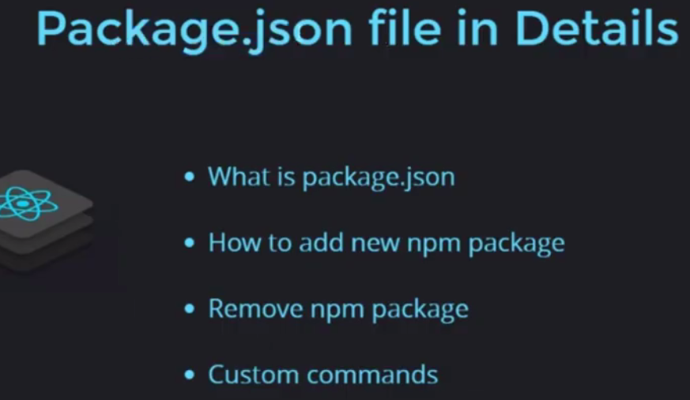

1. So in the previous discussion, package.json we have already discussed.

**Q: How to add new npm package or library in the react js application:**

Let’s say we want to add new library “react validation”

1. Go to npmjs.com and search for react validation.
2. <https://www.npmjs.com/package/react-validation>

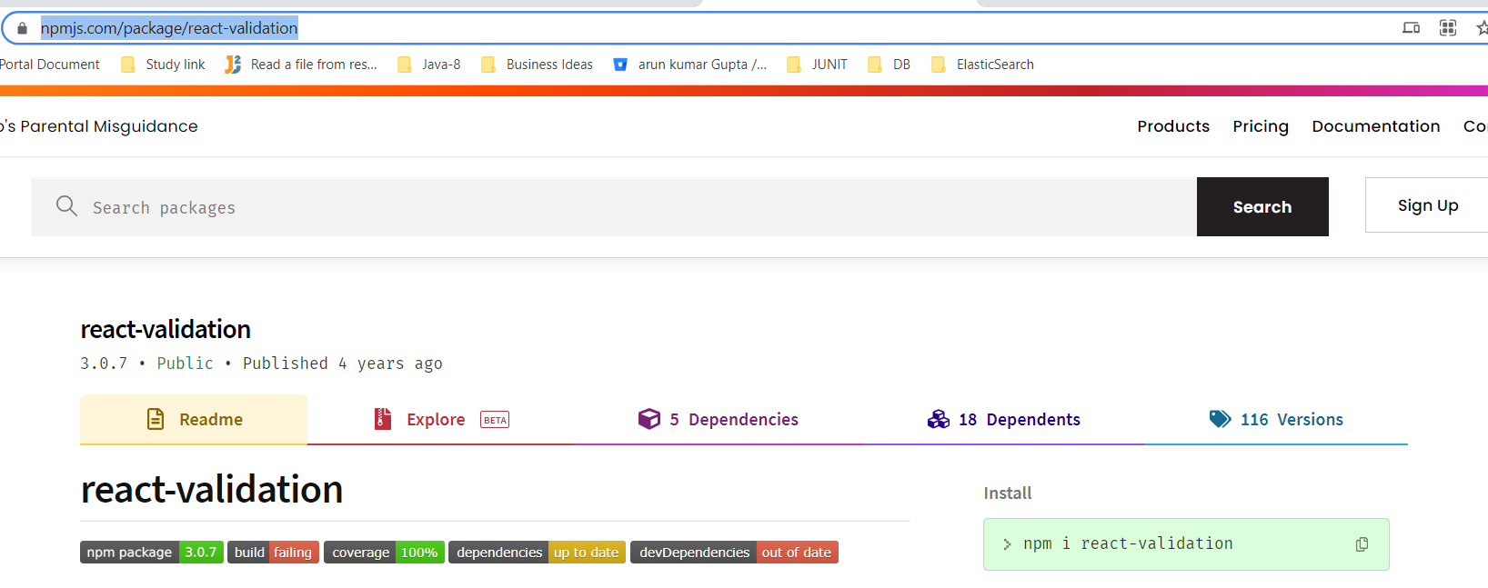

Copy this > npm i react-validation and paste on the command



Once we press enter button it will downloading the package and will put into node_module folder and simultaneously will create one entry inside the package.json

|  |  |
| --- | --- |
| Before | After |

So now we can see the different before and after installing the react-validation package. After installation react-validation entry gets mentioned automatically in the package.json

So this is the one way to install new package in the react application.

Let’s see another way of installing this package in the application.

**In the second** way let’s put the name and version in the package.json and after that in the command prompt run the command [**npm install**].

To remove the installed package we just need to remove the package name from the package.json and run the [npm install] command in the command prompt and it will uninstall the package from the node_package folder also.

**How to create custom command to start your project**? As we know that to start our react js application we have to write command [npm start] and it will start our application. Now if we want to start our application with the name of application then how to create custom command.

|  |  |
| --- | --- |
| "scripts": {  **"start": "react-scripts start",**      "build": "react-scripts build",      "test": "react-scripts test",      "eject": "react-scripts eject"    }  Original | "scripts": {  **"blog": "react-scripts start",**      "build": "react-scripts build",      "test": "react-scripts test",      "eject": "react-scripts eject"    }  Custom |

To start with original command is [npm start]

To start custom command the command is [npm run blog]. So here we have made changes in the script as shown above.

**Q: How many type of component we have in the react js?**

**Component in React Js:**

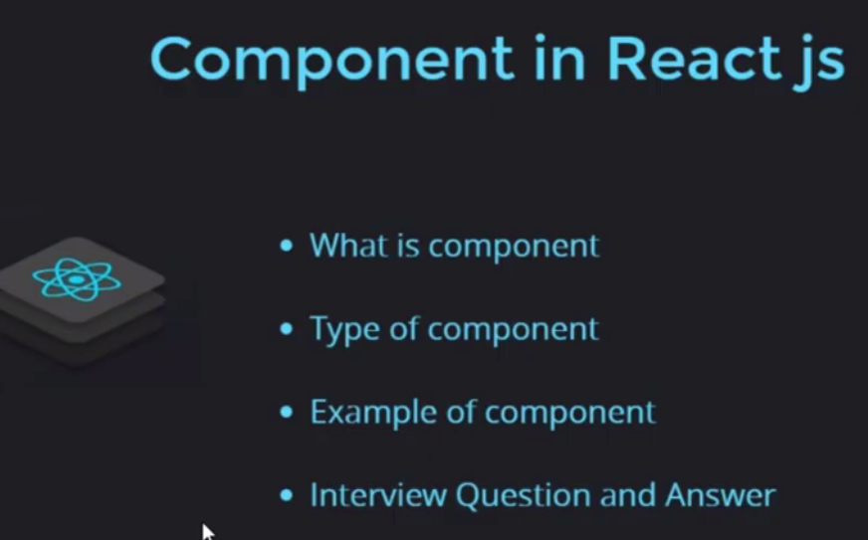

In a lay man word component is a part or element of a large whole i.e. a part of machine.

Now let’s try to understand in terms of react.

1. It is a piece of code that can reuse
2. Example: Header & footer is the best example which can be reused in several places according to need

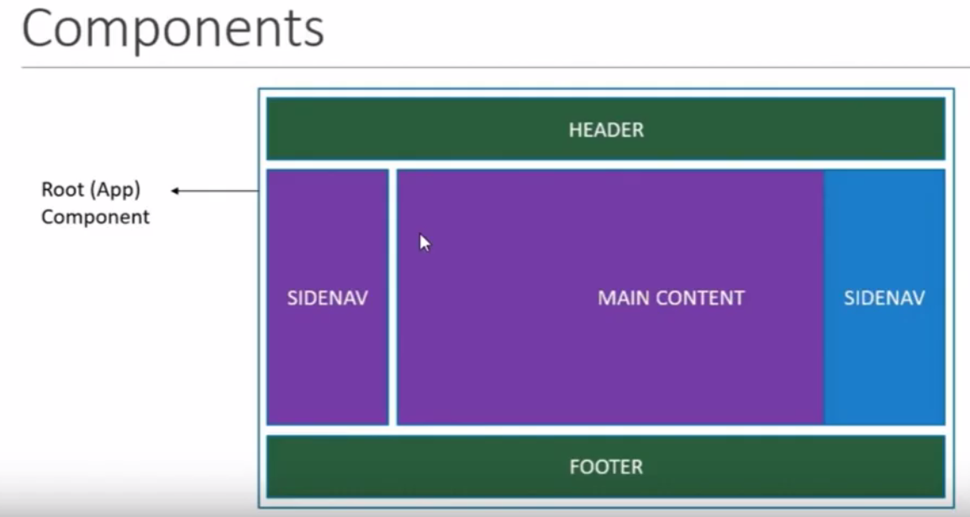

**Types of component:**

|  |  |
| --- | --- |
|  | As here we can see various types of components but actually we have only two types of components.   1. Functional 2. Class   It varies,  We could have another type of components also like  Root component  Container component  **Note**: Generally it is recommended to create one component in one file but it is not mandatory we could have multiple components in one file. |

For example App.js is a component in itself and another example is Users.js that we have created and can be used as component.

|  |  |
| --- | --- |
| Users.js – created as function and will be known as component also.  function Users() {      return (        <div className="App">       <h1> Hello Users from Users function </h1>        </div>      );    }  **export default Users;**  // Here first creating component and then export it | Now import is component in App.js and use as component just like html tag <User />  import logo from './logo.svg';  import './App.css';  import Users from './Users';  function App() {    return (      <div className="App">       Welcome to my first React JS code       <Users />      </div>    );  }  export default App; |
| export  function Users() {      return (        <div className="App">       <h1> Hello Users from Users function </h1>        </div>      );    }  // No use of export default Users because we have used export keyword during component creation only  So here we have used export with the function only and in this case while importing we will import like as given in RHS import {Users} from './Users'; | import logo from './logo.svg';  import './App.css';  import {Users} from './Users';  function App() {    return (      <div className="App">       Welcome to my first React JS code       <Users />      </div>    );  }  export default App; |

Note: the first one is easy and recommended also.

Note: Every component or any messages must be inside <div> </div> tag otherwise we will get error

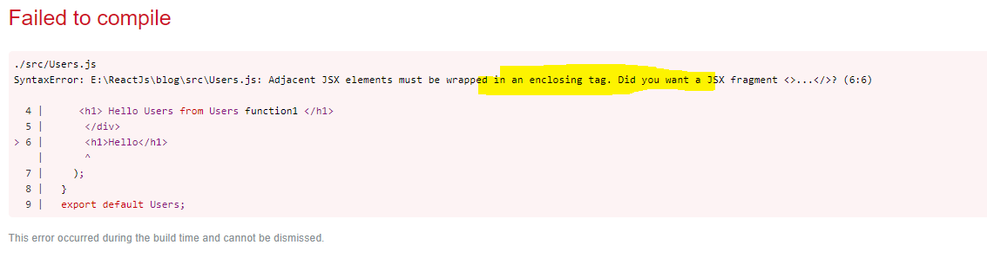So here we have kept <h1>Hello</h1> outside the <div> tag and so we have got the above error.

**Multiple components in the same file:**

**Note**: So far we have created component into new file and then we have imported into App.js, now if want to create the component in the same file only then in that case we can write as given below

|  |  |
| --- | --- |
| import logo from './logo.svg';  import './App.css';  //import Users from './Users';  function App() {    return (      <div className="App">      <h1>Display from App js file</h1>       <Users />      </div>    );  }  function Users() {    return (      <div className="App">     <h1> Hello Users from Users function1 </h1>      </div>    );  }  export default App; | So in this case we don’t need to import Users as this component is available in the same file. And one more thing is we don’t need to use export keyword also.  Since the Users component is being used in the App Component, so this component would be considered as main component of the file and this needs to be exported and that is why we have written  **export default App;** |
|  | Q: Can we write one component inside another component i.e. can we write Users Component inside App component?  Yes we can write one function component into another function component but it would be treated like private function which can be used inside that function only where it is created, outside of the parent function cannot be used. |

Here we have created Apple () function inside App () function and it can be used inside App () function only, outside of App () cannot be used.

**Class Component:**



There is not much different between function component and class component. We can differentiate with the given example.

|  |  |
| --- | --- |
| import React, {Component}from 'react'  export default class **UsersCredentialClass** extends Component{      render(){          return(              <h1>Dispaly from UsersCredentialClass</h1>          )      }  }  The only difference we can see that we have to import React and Component and extends Component. | import logo from './logo.svg';  import './App.css';  import Users from './Users';  **import UsersCredentialClass from './UsersCredentialClass';**  function App() {    return (      <div className="App">      <h1>Display from App js file</h1>       <Users />  **<UsersCredentialClass />**      </div>    );  } |

Another one is we have use render () to return anything.

**Note**: As here we have created class component in a file but we can create this class component inside the **App.js** also

|  |
| --- |
| import logo from './logo.svg';  import './App.css';  import React, {Component}from 'react'  import Users from './Users';  import UsersCredentialClass from './UsersCredentialClass';  function App() {    return (      <div className="App">      <h1>Display from App js file</h1>       <Users />       <UsersCredentialClass />      </div>    );  }  //-----------//writing class component inside App.js----------  class UsersCredentialClass extends Component{    render(){        return(            <div>            <h1>Dispaly from UsersCredentialClass</h1>            <h1>Dispaly from UsersCredentialClass12345 from App js </h1>               </div>        );    }  }  //-------// Writing function component inside App.js itself-------------  function Users() {    return (      <div className="App">     <h1> Hello Users from Users function1 </h1>      </div>    );  }  export default App; |

**But it is recommended to create one component in one file only for more readability and maintenance.**

**App.js: Now after making comment:**

|  |
| --- |
| import logo from './logo.svg';  import './App.css';  import React, {Component}from 'react'  import Users from './Users';  import UsersCredentialClass from './UsersCredentialClass';  function App() {    return (      <div className="App">      <h1>Display from App js file</h1>       <Users />       <UsersCredentialClass />      </div>    );  }  //------wrting class component inside App.js -------------------------  // As recomended to create one component in one file for more readabilit so let's comment the below written component  // and create these two component in seperate file.  /* class UsersCredentialClass extends Component{    render(){        return(            <div>            <h1>Dispaly from UsersCredentialClass</h1>            <h1>Dispaly from UsersCredentialClass12345 from App js </h1>               </div>        );    }  } */  //--------// Writing function component inside App.js itself--------------------  /*  function Users() {    return (      <div className="App">     <h1> Hello Users from Users function1 </h1>      </div>    );  } */  export default App; |
| **UsersCredentialClass.js // Created in separated file**  import React, {Component}from 'react'  export default class UsersCredentialClass extends Component{      render(){          return(              <div>               <h1>Dispaly from UsersCredentialClass</h1>               <h1>Dispaly from UsersCredentialClass12345</h1>              </div>          )      }  } |
| **Users.js: // Created in separate file**  function Users() {      return (        <div className="App">       <h1> Hello Users from Users function1 </h1>        </div>      );    }    export default Users; |

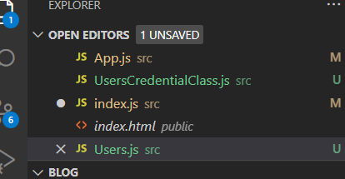

**Creating and calling inner function:**

|  |
| --- |
| import logo from './logo.svg';  import './App.css';  import React, {Component}from 'react'  import Users from './Users';  import UsersCredentialClass from './UsersCredentialClass';  import { render } from '@testing-library/react';  function App() {    function innerFunction(){      render(        <div>This is the inner function created inside App()</div>      );    }    return (      <div className="App">      <h1>Display from App js file</h1>       <Users />       <UsersCredentialClass />       {innerFunction()}       <innerFunction />      </div>    );  } |

1. **Here created an function component inside App() function and we can call this function by two ways:**
2. {innerFunction()}
3. <innerFunction />

**But this innerFunction can be used only in this App() so if we want to use innerFunction feature then first we have to call App() function then this innerfunction () can be used.**

**JSX With React:**

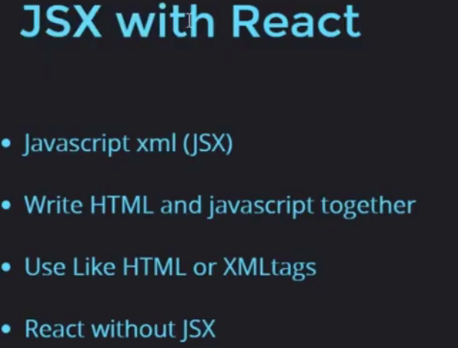

1. This JSX comes with React JS environment setup by default , we don’t need to install from outside
2. Its full name Java Script XML.
3. As we know that if want to write java script and html in one page then to include or to use java script code we use <script> tag and then inside this tag only we can write the java script code but if we try to write java script code into html tag then it is not possible at all and similarly if we want to write html code inside java script code i.e. inside <script></script> then it will not run at all.
4. But here in the above example we have seen that we can write the html tag inside the java script tag. And this is possible just because of JSX (Java Script with XML)
5. So this JSX allows us to write Java Script and html together without using <script> tag.

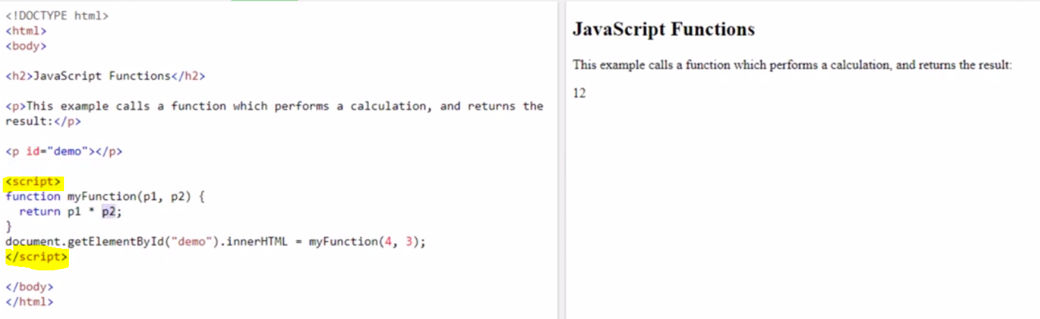

For example here in the normal case we have written java Script code inside <script> tag, without this tag it is not possible to write java script code inside html.

But if we want to write html inside <script> tag then it is not allowed at all as we can see below.

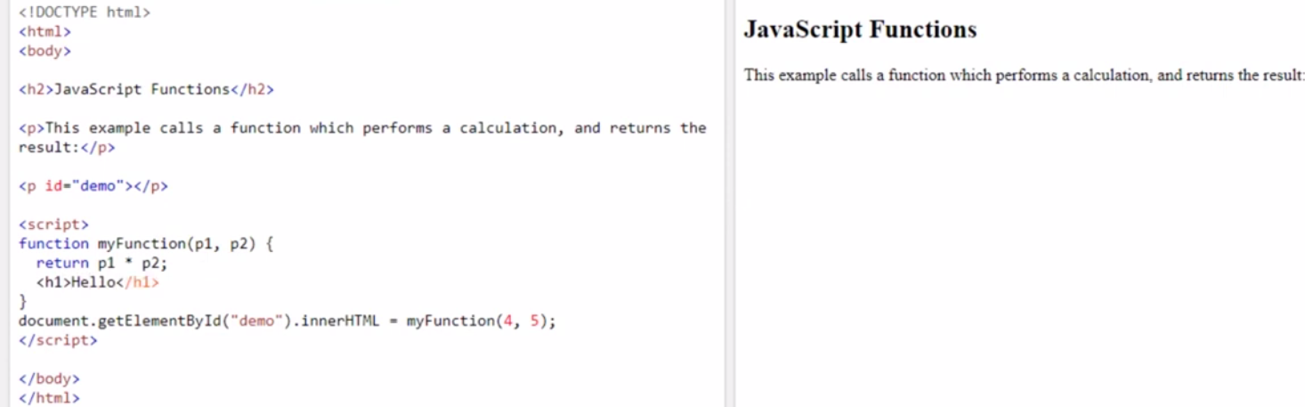

Here we are getting no result because java script code is not getting executed at all because of html written inside <script> tag. But in case of React Js it is allowed and this is because of JSX.

And this can be used just like normal html tag as we have seen earlier example itself e.g. <Users />

**Note**: **Using JSX we can write mathematical operations also**

|  |
| --- |
| function UseJSX(){      return(          <div>6- Addition of Two Numbers(4+3): {4+3}</div>      );  }  export default UseJSX; |

Now import this component inside index.js

|  |
| --- |
| import React from 'react';  import ReactDOM from 'react-dom';  import './index.css';  import App from './App';  import Users from './Users';  import reportWebVitals from './reportWebVitals';  import UseJSX from './UseJSX';  ReactDOM.render(    <React.StrictMode>      <h1>1- Display from Index js file</h1>      <App />      <UseJSX />    </React.StrictMode>,    document.getElementById('root')  );  reportWebVitals(); // Used in measuring performance in your applicatin |

Output: 6- Addition of Two Numbers(4+3): 7

**Q: Can we not write React without JSX?**

A: We can write react app without JSX also but that will be very complicated:

**Example:**

|  |
| --- |
| import React from 'react'  function WithoutJSX(){  return React.createElement('div',null,React.createElement('h1',null,"Hello World without JSX"))  } |

So here if don’t use JSX then to create html element inside React function we have first import React from react and then using the **React.createElement** we have to use html tag. So this will become very complex in case of we have several html tags.

Q- Can we use Angular and React in one project.

A: Since React is a library and Angular is a framework and library can be used in any framework, so react can be used in Angular as well as View js both.

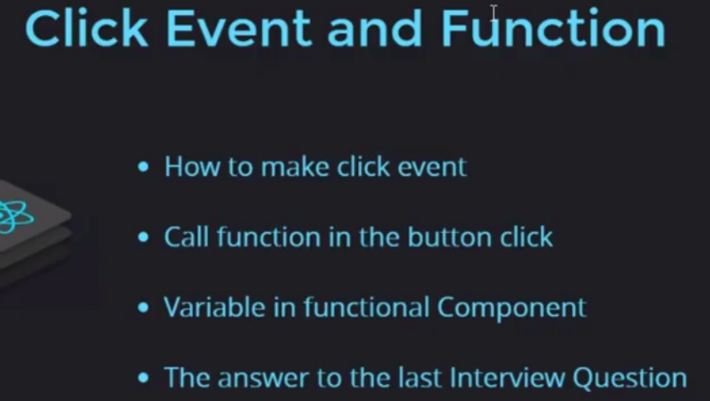

**Click Event and Function**

**Problem statement:**

|  |
| --- |
| function ClickEventAndFunctionCall(){      function apple(){          alert("Apple function is called");      }      return(          <div id="EventClick">              <h1>ClickEventAndFunctionCall </h1>              <button onClick={apple()}>Click Me</button>          </div>      );  }  export default ClickEventAndFunctionCall; |

1. Created a function ClickEventAndFunctionCall
2. Created an inner function apple()
3. Created a button and called this function on onClick Event like: - onClick={apple()}. This is the general syntax to call any function in html tag on click event. But here in case react this syntax is in correct and this will be called automatically on page load and will not be invoked on button click event.

**Solution:** Just remove the () from the alert while calling inside <button> tag. So now the above onclick event will be like:

 <button onClick={apple}>Click Me</button>

Or By using arrow function

**Now it looks perfect**

|  |  |
| --- | --- |
|  |  |

**Calling the alert() directly inside the <button> tag on onclick event:**

 <button onClick={alert("Called Alert Method on click")}>Click Me for alert</button>

But here also we will get same issue this will be called on page load

**Solution:**

 <button onClick={()=>alert("Called Alert Method on click")}>Click Me for alert</button>

So here we have used arrow functionlike: **() =>alert (“Message”): So when we have to call alert() directly inside the button tag then we will use arrow function () =>**

**So now complete correct is given below:**

|  |
| --- |
| function ClickEventAndFunctionCall(){      function apple(){          alert("Apple function is called");      }      return(          <div id="EventClick">              <h1>ClickEventAndFunctionCall </h1>              <button onClick={apple}>Click Me1</button>              <button onClick={()=>apple()}>Click Me2</button>  **<button onClick={()=>alert("Called Alert Method on click")}>Click Me for alert</button>**          </div>      );  }  export default ClickEventAndFunctionCall; |

**We can call this function in App.js or index.js like :** < ClickEventAndFunctionCall />

So these are three ways to call alert function in react js:

**Creating a variable in functional component:**

We can create variable in two ways : 1- using let 2- Using var

|  |
| --- |
| function CreatingVariablefunctionalcompo(){      let name ="ArunGupta is called";      function apple(){          // name="ArunKumarGupta is called now" // line 3          alert(name);      }      return(          <div id="EventClick">              <h1>CreatingVariablefunctionalcompo: {name} </h1>              <button onClick={apple}>Click Me1</button>              <button onClick={()=>apple()}>Click Me2</button>              <button onClick={()=>alert("Called Alert Method on click")}>Click Me for alert</button>          </div>      );  }  export default CreatingVariablefunctionalcompo; |

1. Created one variable as : [ let name ="ArunGupta is called";]
2. Now pass this variable in the alert() of apple() function
3. Now when this method will called then name variable value will be displayed and same name value will displayed in the <h1> tag

Now let’s change the name variable value: So if uncomment the line 3 then in the alert message the modified message will displayed on onClick event. But in the <h1> tag this change will not be shown.

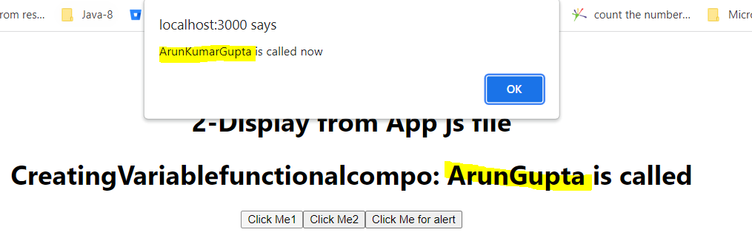

**Solution**: We can solve this issue by using state and probes: we will see in the coming topic:

So it is recommended to not to use directly use of variable



**State in Functional Component:**

As in the last section we have tried to update variable in the functional component but it did not changed. So we can achieve this by using stat in the functional component.

**What is state?**

State is an object just like variable where we store the data, in the same way we can store the data in the state.

**Why to use state?**

When we use variable with some value in the component and if we want to update the variable value then this variable value does not update in the component on any event fire (onClick). But if we use **state** and fire any event like onClick then the entire component gets re-render and update in the state of object.

The reason behind is that while using simple variable then at the time of page load first time whatever the value is stored in the variable is used in the component but let’s say later on some place we have updated the variable value and now if we fire any event like onClick then now in this case entire component does not re-render only the that part of the code will be re-render which is getting called on onClick event. But in case of state when we fire click event then entire component gets re-render and in this way the updated value start reflecting in the component. That is why we have to use state.

The state can define in React Only but variable came from JavaScript so it can be use any of the scripting language like Angular JS or View JS.

**Define State:1.29.23**

|  |
| --- |
| import React from "react";  // OR import {useState} from "react";  function CreatingStateInFunctionalComponent(){      //let data="Arun";      let [data,setData]=React.useState("Arun");      function updateData(){          // data="Bunty";          setData("Bunty");          alert(data+" is called!!!");      }      console.info("------CreatingStateInFunctionalComponent-------");      return(          <div id="stateEx">              <h1>{data}</h1>              <button onClick={updateData}>Click To Change State</button>          </div>      );  }  export default CreatingStateInFunctionalComponent; |

1. **Imported React from react**
2. **Using React.useState declare one array or container which has its initial value(data) and variable(setData) to update**
3. **Now wherever we want to update this data we can use setData and update the initial value**
4. **Now when we click on the button then it fire an onClick event and reload the react js and hence the initial value state became updated and we get the updated state of the variable.**

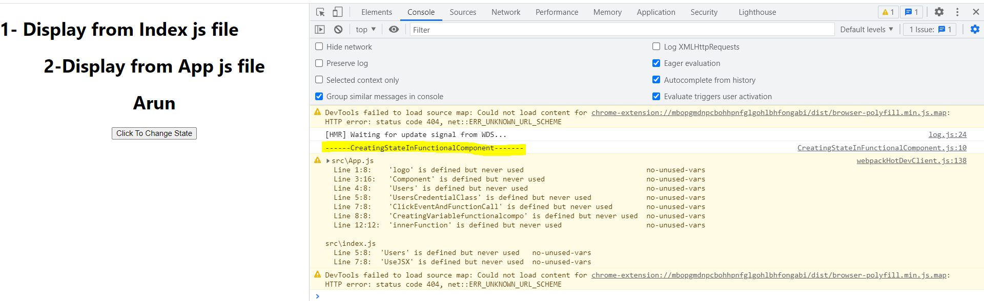

**Page load status before clicking on button we can see the log in the console.**

**Now let’s click on the button and then again it will load the entire page**

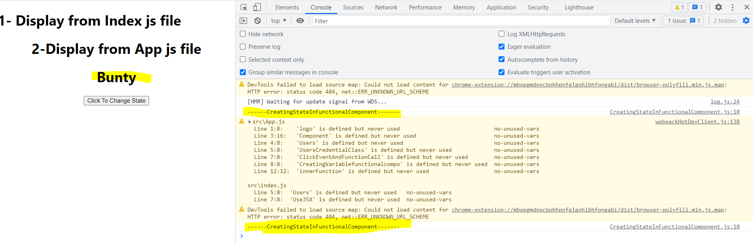

Now we can see that once the onClick events get fired it loads the page again and thus the state of variable gets changed and we got the updated variable value. And we can see that console log gets printed two times.

**Example to increase number using state variable:**

|  |
| --- |
| import React from "react";  // OR import {useState} from "react";  function CreatingStateInFunctionalComponent(){      //let data="Arun";      //let [data,setData]=React.useState("Arun");      let [data,setData]=React.useState(0);      function updateData(){          // data="Bunty";         // setData("Bunty");          setData(data+1)          alert(data+1+" is called!!!");      }      console.info("------CreatingStateInFunctionalComponent-------");      return(          <div id="stateEx">              <h1>{data}</h1>              <button onClick={updateData}>Click To Change State</button>          </div>      );  }  export default CreatingStateInFunctionalComponent; |

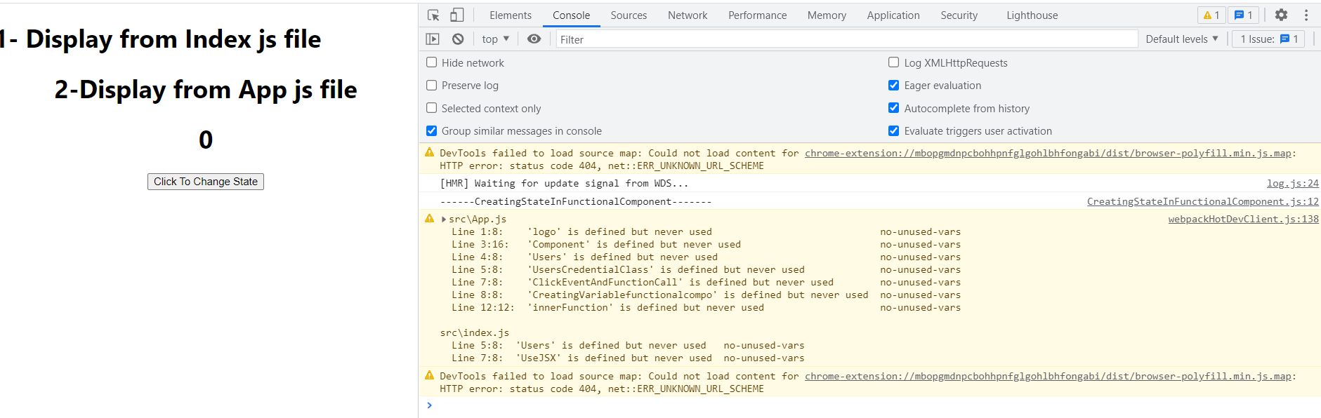

**Now when we click on button number will increase by one.**

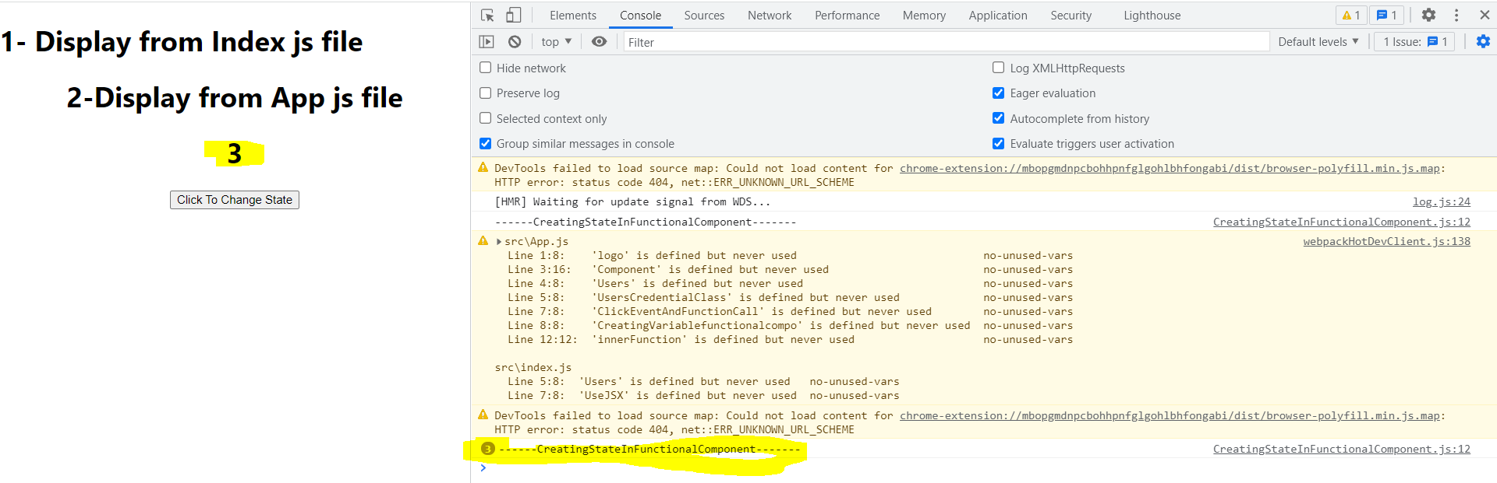

**Hence number getting increase by one on each click and console log is also getting printed accordingly. Hence we can see that on each click it re-render the entire component.**

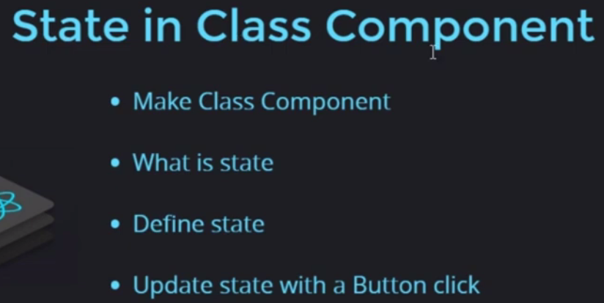

**State in Class Component:**

As it is recommended to use functional component mostly, in the beginning when React was introduced then Class component was most popular.

There is a bit difference of using state in class component in compare to functional component.

|  |
| --- |
| import React from "react";  // OR import React, { Component } from "react"; In this case we dont need to write React.Component  class StateInClassComponent extends React.Component{      constructor(){          super();          this.state={              data:"Arun",              number:1          }      }      updateData() {          this.setState({data:"Bunty"})          this.setState({number:this.state.number+1})      }      render(){          return(              <div className="StateInClassComponent">                <h1>Use of State in Class Component !!!+{this.state.data}+{this.state.number}</h1>                  <button onClick={()=>this.updateData()}>Update</button>              </div>          );      }  }  export default StateInClassComponent; |

1. First import React from react
2. Create a user defined class and extend the Component from React
3. Create a constructor and inside this declare super(); and declare the state as given above
4. Now create a function updateData where we are updating the data value using setState method
5. Now calling this method onClick event

Output:

|  |
| --- |
|  |
| Now as soon as we click on update: |

Now data value gets updated onClick event

So in this way we can use state in Class.

Q: Can we use the state outside of the component:

A: Yes we can. But it is not recommended to use

Q: State of react is public or private?

A: public



**Props with Functional Component:**

**What are props?** : This nothing but just like the parameter or argument passed inside any method in JavaScript. But in case of react this is called props which get passed inside the functional component. Here props is nothing but the properties.

**How create and use props?**

|  |
| --- |
| function StudentProps(props) {      console.log(props);      return(          <div style={{backgroundColor:"lightblue", margin:10}}>              <h1>Hello Student:{props.name}</h1>              <h1>Email: {props.email}</h1>              <h1>Address: {props.others.Address}</h1>              <h1>Mobile: {props.others.mobile}</h1>          </div>      );  }  export default StudentProps; |

1. Created on functional component with parameter or props
2. We are getting this props values from the App.js where this component is getting called with props (parameters) values

|  |
| --- |
| import './App.css';  import React, {Component}from 'react'  import { render } from '@testing-library/react';  import StudentProps from './StudentProps';  function App() {    function innerFunction(){      render(        <div>5- This is the inner function created inside App()</div>      );    }    return (      <div className="App">      <h1>2-Display from App js file</h1>      <StudentProps name ={"Arun"} email={"arun@test.com"} others={{Address:"Delhi",mobile: "0000"}}/>      <StudentProps name ={"Bunty"} email={"Bunty@test.com"} others={{Address:"Bangalore",mobile: "1111"}}/>       {/* <StateInClassComponent /> */}      </div>    );  }  export default App; |

**Explanation: 1.56.24**

1. **So here in the above Apps.js component we are calling the functional component StudentProps**
2. **Along with the function call we are passing the parameters with their values this is called props**
3. **Here we are passing simple props[**name ={"Bunty"} email={"Bunty@test.com"} ] **as well as arrays of props [**others={{Address:"Bangalore”, mobile: "1111"}}]
4. **Now to access this props values in the StudentProps : [**{props.name}, {props.email}]
5. **Accessing the arrays props: [**{props.others.Address},{props.others.mobile}]

**Note:** during accessing the props values in StudentProps.js, we have to use the same name what we have used during the function call in the App.js**.**

**We can see the same in console:**

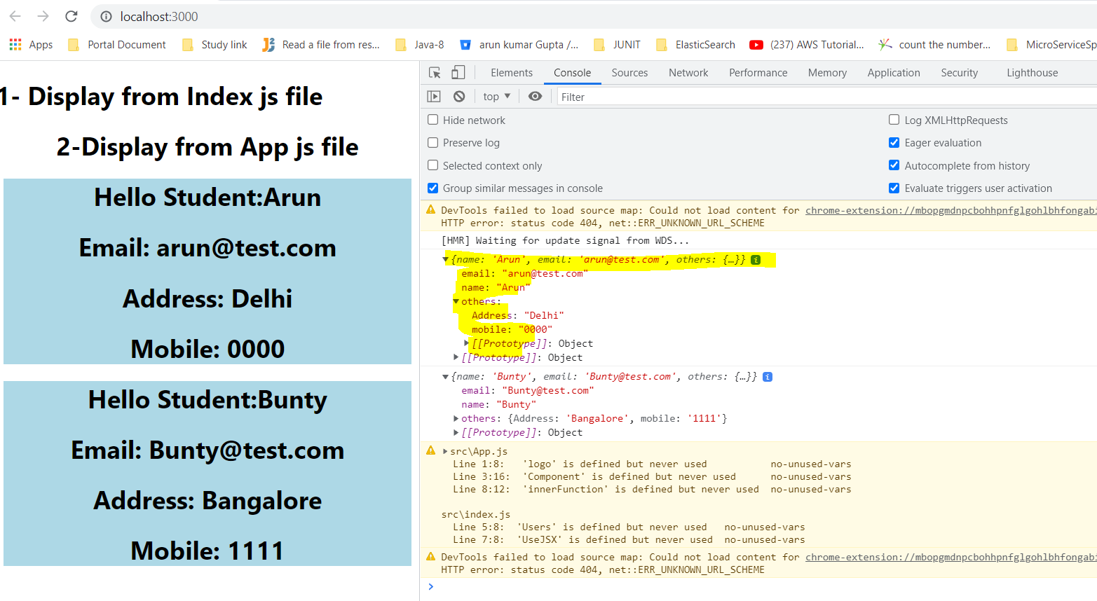

**So this is the way we can use the props**

**Update the props:**

|  |
| --- |
| import logo from './logo.svg';  import './App.css';  import React, { Component, useState } from 'react'  import { render } from '@testing-library/react';  import StudentProps from './StudentProps';  function App() {    const [name, setName] = useState("Bunty");    const [email, setEmail] = useState("abc@test.com");    function updateProps() {      setName("Bunty23");      setEmail("bunty@test.com");    }    return (      <div className="App">        <h1>2-Display from App js file</h1>        <StudentProps name={"Arun"} email={"arun@test.com"} others={{ Address: "Delhi", mobile: "0000" }} />        <StudentProps name={name} email={email} others={{ Address: "Bangalore", mobile: "1111" }} />        <button onClick={() => updateProps()}>update props</button>      </div>    );  }  export default App; |

To update the props:

1. Imported useState from react
2. Created the const using useState and provide the default name and set property
3. Created a function updateProps() and setting the name and email to be update on click of button
4. Create a button and onClick event call this updateProps() function

|  |  |
| --- | --- |
| Before update the default set value: | After clicking on update: updated state of props are: |

So this way we can update the props value

Q: Can we use useState inside the class component also?

A: No

Q: As in the above example we have

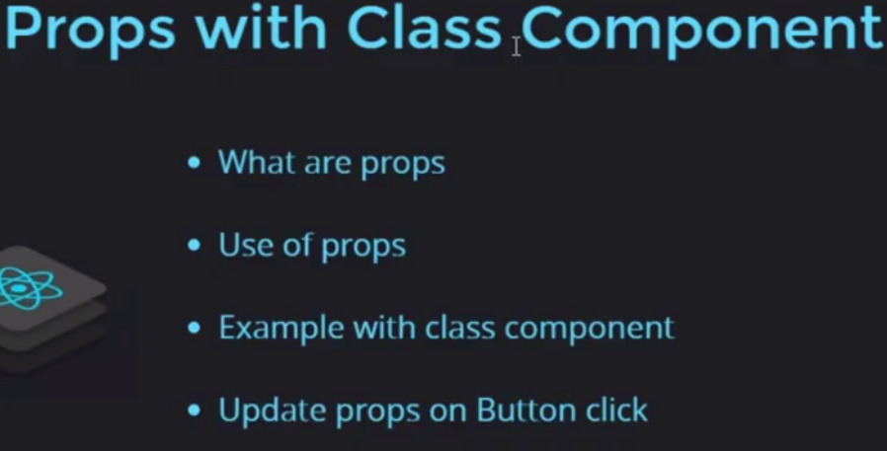

**Props with Class Component:**

When we want to transfer data from one component to another component then we can use props. It is basically equivalent to parameter which is passed to function and can receive these value in its definition. In other word the parameter passed in the function is called parameter or argument in the same way the parameter passed in the component is called props.

**Example of class Component:**

|  |
| --- |
| import logo from './logo.svg';  import './App.css';  import React, { Component, useState } from 'react'  import { render } from '@testing-library/react';  import StudentProps from './StudentProps';  import StudentClassPropsUse from './StudentClassPropsUse';  function App() {    const [name, setName] = useState("default");    const [email, setEmail] = useState("default@test.com");    function updateProps() {      setName("Bunty23");      setEmail("bunty@test.com");    }    return (      <div className="App">        <h1>2-Display from App js file</h1>        <StudentClassPropsUse name={"Santosh"} email={"santosh@test.com"} />        <StudentClassPropsUse name={name} email={email} />        <button onClick={() => updateProps()}>update props</button>      </div>    );  }  export default App; |

In the App.js there is difference between functional component and class component for passing props during invoke

|  |
| --- |
| import React from "react";  class StudentClassPropsUse extends React.Component{      render(){          console.log("Entire props passed in the component::");          console.log(this.props);          return(              <div style={{backgroundColor:"skyblue", margin:20}}>                  <h1>Use of props in class</h1>                  <h2>Name: {this.props.name}</h2>                  <h3>Email: {this.props.email}</h3>              </div>          );      }  }  export default StudentClassPropsUse; |

The only difference I found that to access the props here we have to use [this] because this is the class component and we cannot pass the parameter from function to a class i.e. it is possible from function to function that is why to access the props we have used this, which represents the current object or props passed during the invocation in the App.js

**Q: Can we send html inside props?**

A: Yes: we have to use {**this.props.children**} in class component to get html and {**this.children**} in case of functional component.

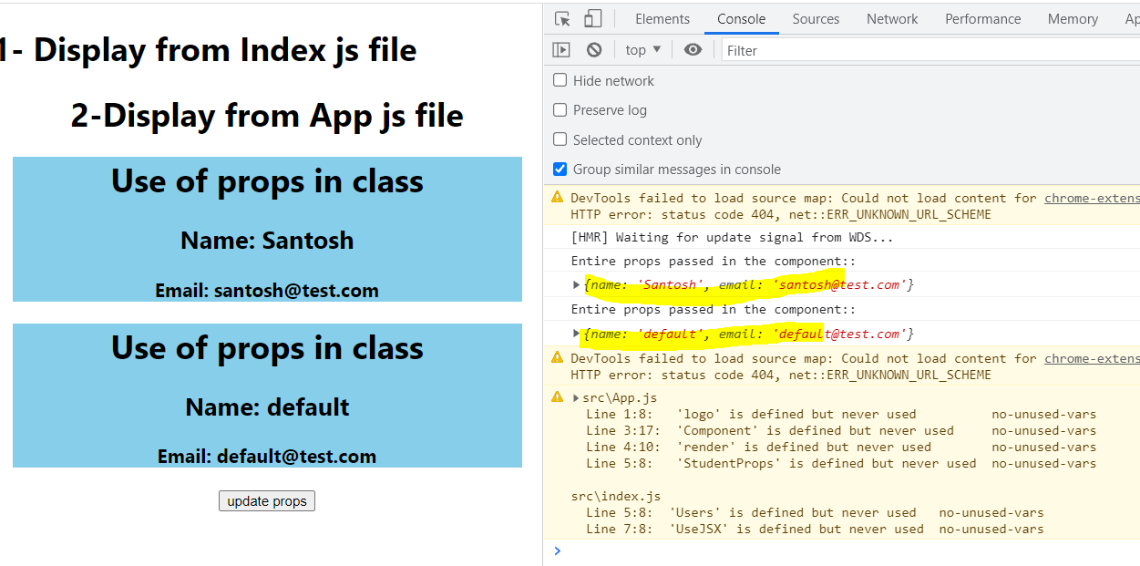

Now let’s click update button and see the change in the props:

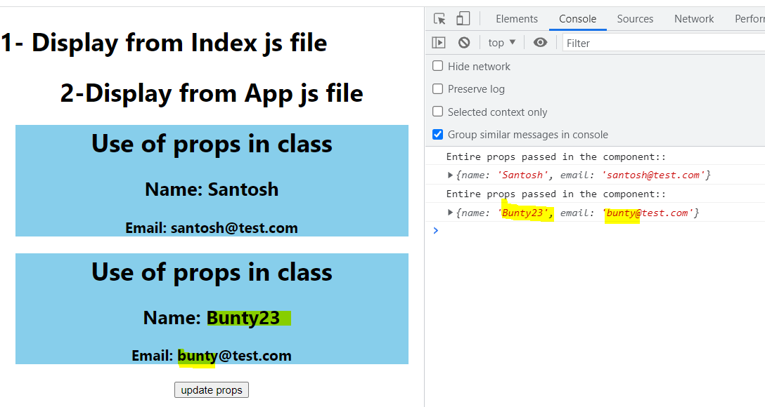

So this is the way we can use the props in class and can update also:

Note: In case of class component we can perform update using constructor. As given below:

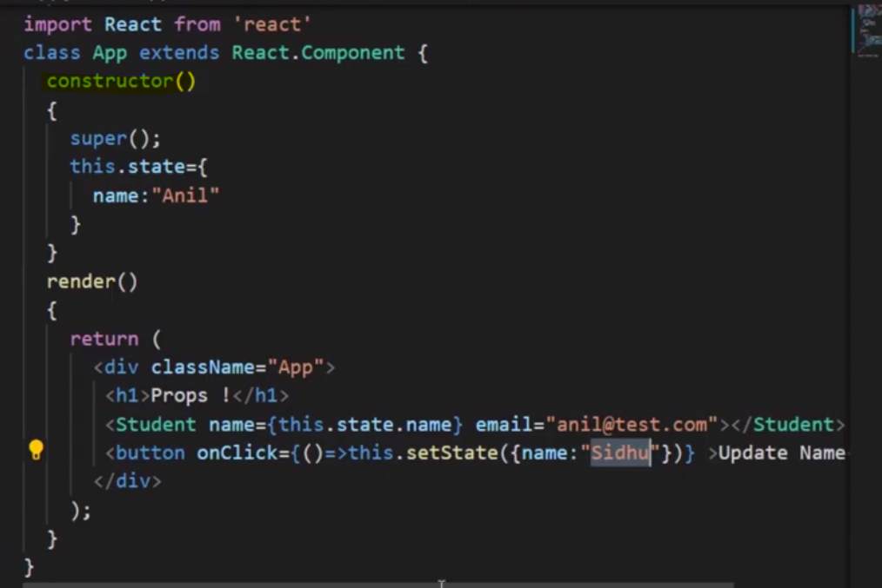

**Getting value from input box:**



|  |
| --- |
| import React from "react";  function GetInputBoxAndPrintValue() {      const[inputData, setInputData]=React.useState(null);      function getData(inputVal) {          setInputData(inputVal.target.value)      }      return(          <div>              <h1>Hello: {inputData}</h1>              Name: <input type="text" onChange={getData}/>          </div>      );  }  export default GetInputBoxAndPrintValue; |

1. Import React from react so that we can has useState to update the state
2. Created constant with [inputData, setInputData], to have default value and change the state
3. Created a function which get the input from the text box and will set the same into setInputData

|  |  |
| --- | --- |
|  |  |

So we can see that onChange event it calls the getData method and whatever value we are giving as input it set the data using setInputData into inputData and same value is getting printed in {inputData}.

**Getting Or Printing input Data on click event:**

|  |
| --- |
| import React from "react";  function GetInputBoxAndPrintValue() {      const[inputData, setInputData]=React.useState(null);      const[printData, setPrintData]=React.useState(false);      function getData(inputVal) {          setInputData(inputVal.target.value)      }      return(          <div>              {                  printData?                  <h1>Hello: {inputData}</h1>                  :null              }              Name: <input type="text" onChange={getData}/>              <button onClick={()=>setPrintData(true)}>Print data</button>          </div>      );  } export default GetInputBoxAndPrintValue; |

So here onClick event we are making setPrintData true using setPrintData (true), and if printData is true then show the <h1>Hello: {inputData}</h1> with input data given into input box else print null.

|  |  |
| --- | --- |
| **So we can hide and show the input value using useState** | Now provide input and click on print Data: |

**Toggle or Hide and show the elements:**

|  |
| --- |
| import React from "react";  function HideAndShowElement() {      const[status,setStatus]=React.useState(true);      return(          <div className="HideAndShowElement">              {status?  <h1>Hello Arun</h1> : null}              <button onClick={()=>{setStatus(true)}}>Show</button>              <button onClick={()=>{setStatus(false)}}>Hide</button>          </div>      );  }  export default HideAndShowElement; |

1. So here we have not done anything new, we have just taken status and setStatus useState and taken default status as true.
2. Now created two button Show and Hide
3. Now to hide the element we are checking if status is true [status ?] then show the element else mentioning null
4. Now in the show button, onClick event we are setting status value as true using setStatus useState
5. In the Hide button, onClick event we are setting status value as false using setStatus useState
6. Call this function in App.js <HideAndShowElement />

|  |  |
| --- | --- |
|  |  |

So this way we can show and hide the html element.

**Toggle the Html element:**

|  |
| --- |
| import React from "react";  function ToggleElement() {      const[status,setStatus]=React.useState(true);      return(          <div>              {status? <h1>Hello Arun</h1>: <h1>Hello Bunty</h1>}                <button onClick={()=>setStatus(!status)}>Toggle</button>          </div>      );  }  export default ToggleElement; |

So here we have just passed the negation of status in the setStatus i.e. (! status)

If status is true then show [Hello Arun] and hide [Hello Bunty] and again status is false then show [Hello Bunty]

|  |  |
| --- | --- |
|  | Now when we click on the Toggle button its value will be set to false and element will hide. |

So this is the way we can toggle the element:

Q: What is the difference between the toggling in JQuery and React? Are we using css for toggling element in JQuery?

**Basic Form in React:**

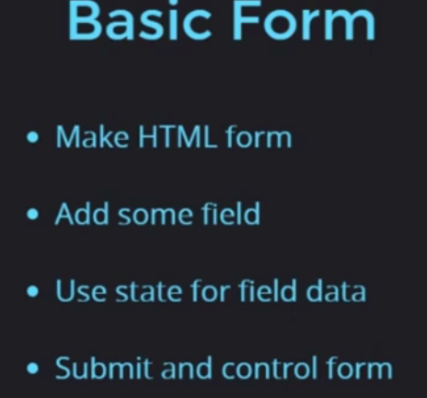

First of all let’s design the simple form in React:

|  |
| --- |
| import React from "react";  function FormHandling(){      return(          <div>              <form>                  <h1>Handling form and its input</h1>                  <h3>Enter the input</h3>                  <input type="text" placeholder="Enter Name" /><br /><br />                  <select>                      <option>Select option</option>                      <option>One</option>                      <option>Two</option>                      <option>Three</option>                  </select> <br /><br />                  <input type="checkbox" /><span>Accept Terms and Conditions</span><br /><br />                  <button type="submit">Submit</button>              </form>          </div>      );  }  export default FormHandling; |

Output:

|  |
| --- |
|  |

Now let’s hander the form data.

1. Let’s create three useState for input text, select box and check box
2. Let’s create three methods. (1)- for setting input text (2)- for setting select box (3)-for setting check box
3. Now in each method set the value using useState set props
4. Now call these method-1 onChange event in case of input text and pass the event as event parameter
5. Call the method-2 onChange event in case of select box and pass the event as parameter
6. Call the method-3 onChange event in case of check box
7. Finally inside the <form> tag call one method on onSubmit event where we will call one method to prevent form submit and print all the form data into logs

|  |
| --- |
| import React from "react";  function FormHandling(){      // Let's define the useState for input text, select box, & checkbox      const[inputText, setInputText]=React.useState("");      const[selectBox, setSelectBox]=React.useState("");      const[checkBox, setCheckBox]= React.useState(false);      function getFormData(event){          console.log(inputText,selectBox,checkBox);          event.preventDefault();  // prevent in submitting form, if we dont use this line then form will be submit on click.      }      function updateInputText(event){          setInputText(event.target.value); // setting the value from, form input text      }      function updateSelectBox(event){          setSelectBox(event.target.value); // setting the value from, form select box      }      function updateCheckBox(event){          setCheckBox(event.target.checked); // Here we have to set value as checked      }      return(          <div className="FormHandling">              <form onSubmit={getFormData}>                  <h1>Handling form and its input</h1>                  <h3>Enter the input</h3>         <input type="text" placeholder="Enter Name" onChange={(event)=>{updateInputText(event)}}/>  <br /><br />                  <select onChange={(event)=>{updateSelectBox(event)}}>                      <option>Select option</option>                      <option>One</option>                      <option>Two</option>                      <option>Three</option>                  </select> <br /><br />    <input type="checkbox" onChange={(event)=>{updateCheckBox(event)}}/>  <span>Accept Terms and Conditions</span>  <br /><br />                  <button type="submit">Submit</button>              </form>          </div>      );  }  export default FormHandling; |

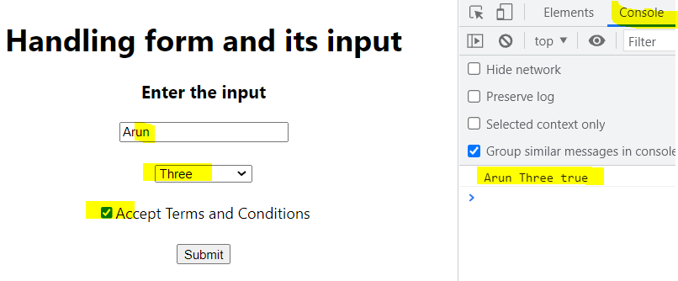

**In this way we can hand the form data in react js.**

**Conditional Rendering | If Condition : Here we will see if-else and Else-if**

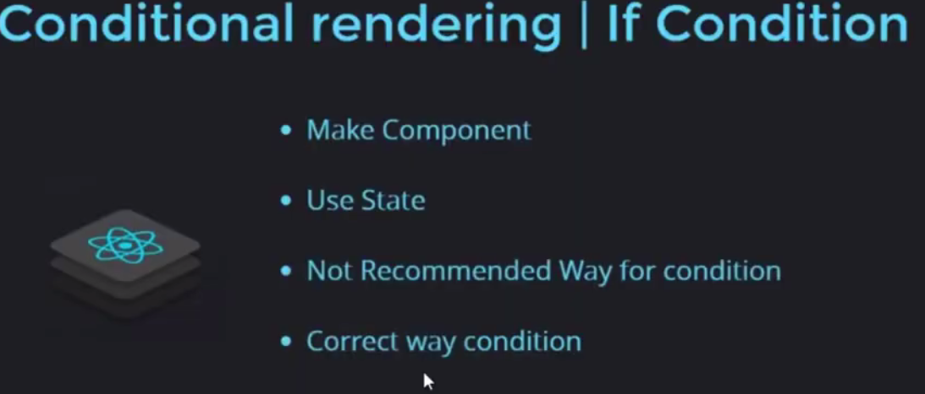

**Using if-else condition:**

|  |
| --- |
| import React from "react";  function ConditionalRendering(){      const[loggedIn, setLoggedIn]=React.useState(true);      if(loggedIn){          return(              <div>                  <h1>Conditional Rendering!!</h1>                  <h2>User-1 Logged in</h2>              </div>          );      }      else{          return(              <div>                  <h1>Conditional Rendering!!</h1>                  <h2>Guest user Logged in</h2>              </div>          );      }  }  export default ConditionalRendering; |

|  |  |
| --- | --- |
| **if loggedIn is true:** | **Else** |

So we did not get any issue and every things looks good, but this is not recommended because we have to write big chunk of code in both the condition with return () .

**Recommended: User ternary operator: Correct way**

|  |
| --- |
| import React from "react";  function ConditionalRenderingUsingTernoryOP(){      const[loggedIn, setLoggedIn]=React.useState(false);      const[number, setNumber]=React.useState(2);      return(          <div>              {loggedIn? <h1>User Logged In</h1> :<h1>Guest Logged in</h1>}              {number==1? <h1>One</h1>: number==2? <h1>Two</h1> :<h1>Three</h1>}          </div>      );  }  export default ConditionalRenderingUsingTernoryOP; |

Here we have used ternary operator to check multiple condition. If logged in is true then User Logged In else Guest Logged in.

Similarly multiple conditions we can check by using numbers:

**Passing Function as Props:2.46.29**

1. Create a child component
2. Include this child component element into App.js. Now in the App function create one inner function with alert message.
3. Now pass this inner function inside the child component element as a props
4. Now in the child element calls this function on button click

|  |
| --- |
| import React from "react";  function PassingFunctionAsProps(props){      return(          <div>              <h1>Passing Function as Props- function Name::{props.data.name}</h1>              <h2>Name from Child: {props.name}</h2>              <h2>email from Child: {props.email}</h2>              <button onClick={props.data}>Click Here</button>          </div>      );  }  export default PassingFunctionAsProps; |

Created one child component where onClick event calling the function of parent component {props.data}

|  |
| --- |
| import './App.css';  import React, { Component, useState } from 'react'  import PassingFunctionAsProps from './PassingFunctionAsProps';  function App() {    const [name, setName] = useState("default");    const [email, setEmail] = useState("default@test.com");    function updateProps() {      setName("Bunty23");      setEmail("bunty@test.com");      alert("Passing functions as props:"+name +"-"+email);    }    return (      <div className="App">        <h1>Name From App: {name}</h1>        <h2>Email From App: {email}</h2>        <PassingFunctionAsProps data={updateProps} name={name} email={email}/>      </div>    );  }  export default App; |

Here created on inner function **updateProps ()** and passing the function as props in the child element.

Output:

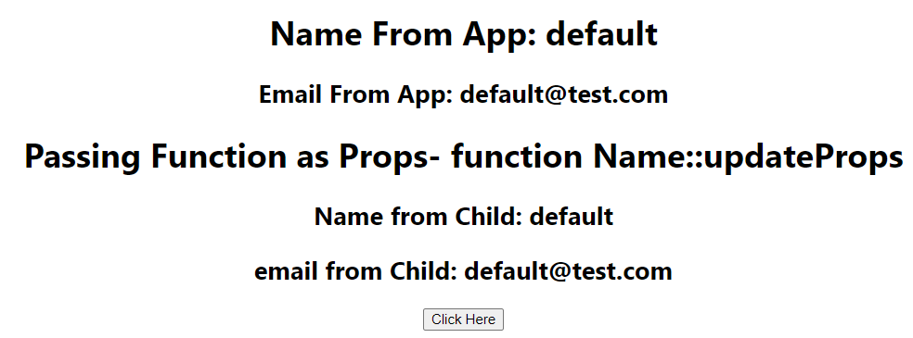

Now let’s click on button:

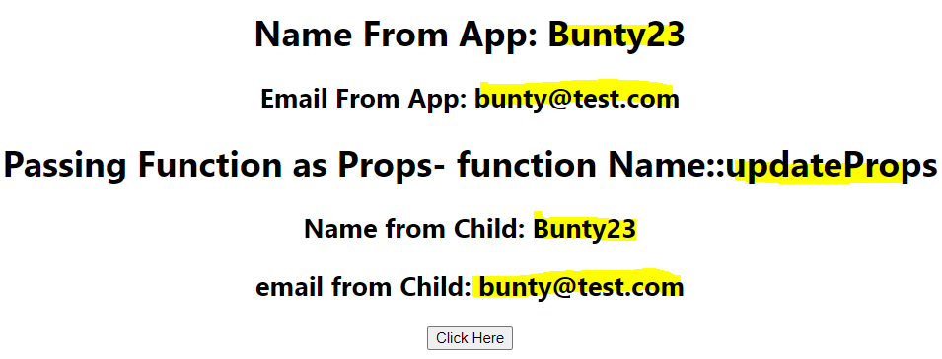

We can see that on clicking of button it calls the method define in the parent component: Hence we can call the function as props:

Q: Can we call child function inside its sub-child component?

**React Life cycle Methods:**

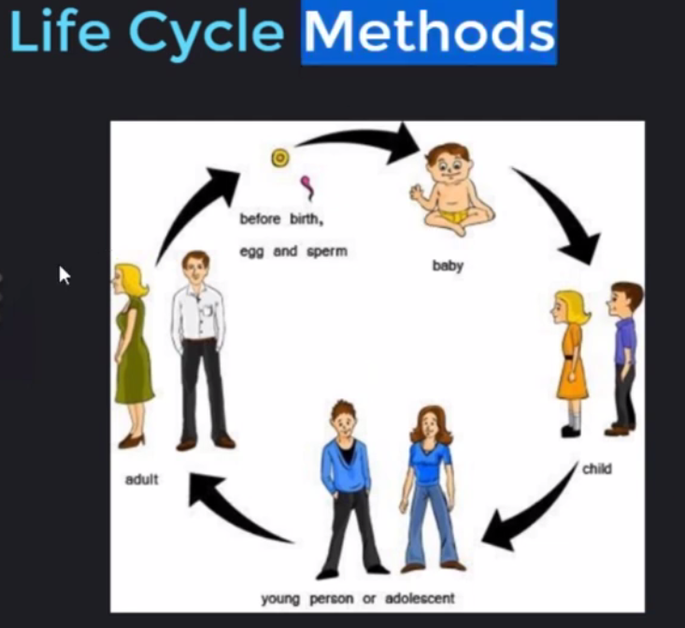

Here we have shown the life cycle of a human being. In the Human life cycle.

1. Birth
2. Multiple action (update) performed during his whole life cycle
3. Finally death

So we can see that basically we have three phase in the human life cycle, in the same we way we have three phase in the Life cycle method in React as shown below.

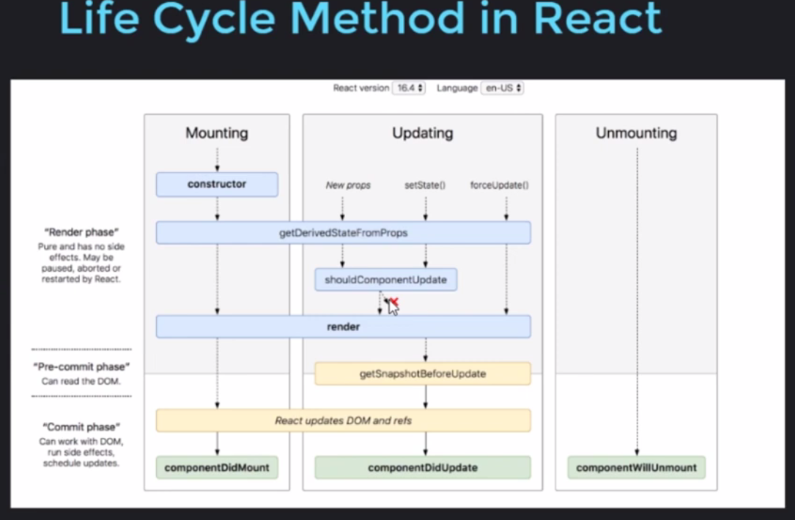

**Mounting**: Here in this phase the entire component will mount. In short the react page will load first into DOM.

**Updating**: Once the Mounting phase completes i.e. page gets loaded completely then we can perform several update operation, like method call, updating props.

**Unmounting**: Finally when all the update completes then component will unmount, i.e. react page will start un-loading from the DOM

**Q**: Where we can use this life cycle method:

**A**: we can use this life cycle method in functional component as well as in class component.

**When the life cycle method will be executed:**

A:

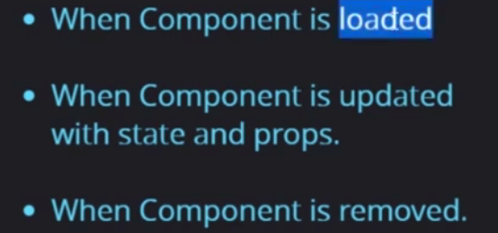

**First of all let’s learn the Life cycle method in class component:**

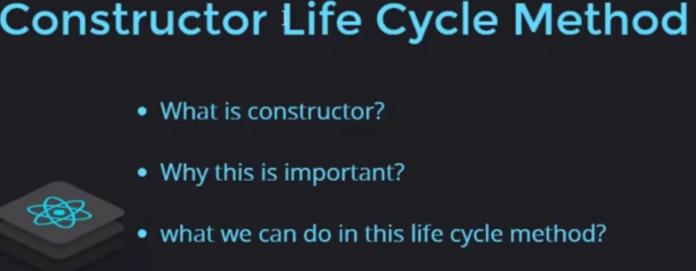

If we talk about the life cycle method in the class component then after loading the component of the class the first method which gets executed is – constructor. It plays a very important role when we want to perform some activity before rendering, because if we render first and then perform any action to display then we will not get correct result.

For example we can define the state of the props.

|  |
| --- |
| import React from "react";  class ClassComponentLifeCyfleMethod extends React.Component{      constructor(){          super();          console.log("1- Message from constructor");          this.state={              data:"Arun"          }      }      render(){          console.log("2- Message from render");          return(              <div>                  <h1>Class Component Life Cycle::{this.state.data}</h1>              </div>          );      }  }  export default ClassComponentLifeCyfleMethod; |

|  |
| --- |
|  |
|  |

Here we put two console logs. Now when we run this component then console log inside the constructor will execute first and then console log inside render will then execute. So we can see that in the class component life cycle method constructor execute first.

Q: when we hide any component and show it again then, a new life cycle will start or same life cycle will execute:

A: A new life cycle will start.

**Render Life cycle Method:**

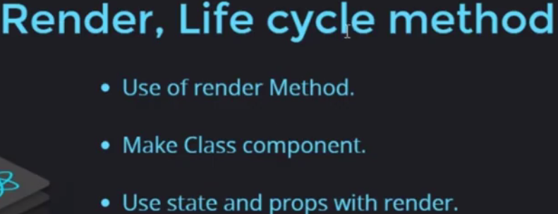

1. Render method is to execute the html content written inside render method and represent it to the user. In case of class component all the html content written inside render() method only
2. Whenever we make any changes in the html then this render() will execute every time to present the updated html element to the user
3. One more thing is whenever any state or props get updated then render () method execute automatically to have updated state and props in the html content.

So if we talk about its life cycle then render () gets call as listed below

1. First time whenever the component is ready at the time loading
2. Whenever we update the state or props
3. Whenever we update the html content

|  |  |
| --- | --- |
| import React from "react";  class ClassComponentLifeCyfleMethod extends React.Component{      constructor(){          super();          console.log("1- Message from constructor");          this.state={              data:"initailClassState"          }      }      render(){          console.log("2- Message from render");          return(              <div>                  <h3>Class Component Life Cycle::{this.state.data}</h3>                  <h3>Apps  Component state value::{this.props.name}</h3>                  <button onClick={()=>this.setState({data:"UpdateClassState"})}>update state</button>              </div>          );      }  }  export default ClassComponentLifeCyfleMethod; | |
| App.js  function App() {    const[name,setName]=React.useState("Arun");    return (      <div className="App">       <ClassComponentLifeCyfleMethod name={name}/>        <button onClick={()=>{setName("Bunty")}}>Update</button>      </div>    );  }  export default App; | |
|  |  |
|  | Here render method will execute.   1. First of all the react page gets loaded 2. Second when we click on button to update state the name 3. Third when we click on update to update props |

Q: can we write render() inside render() method

**ComponentDidMount Life Cycle Method:**



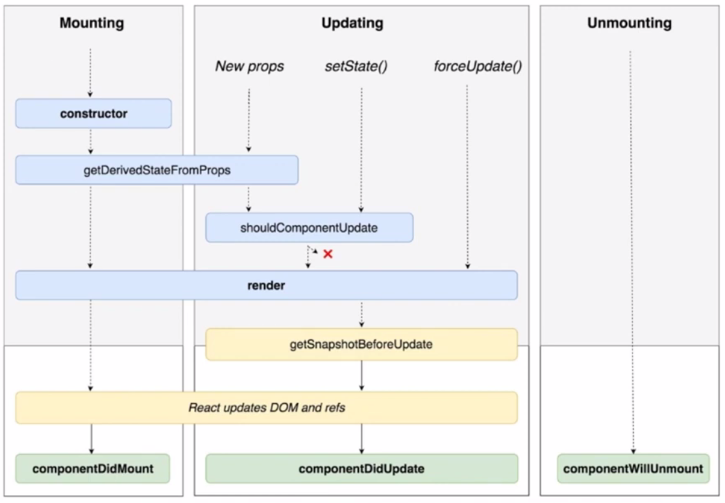

As we know that in the class component life cycle.

1. First off all construct of the class will be called
2. Then render() method will be called
3. And finally when all the component like html or DOM is ready then this componentDidMount() will be called

Use of ComponentDidMount:

1. Whenever we want call any API then this will be used.
2. Or whenever we want to do some hide or show then this will be done here in this method
3. In short whenever the action which needs to perform after loading of complete HTML or DOM
4. This life cycle method will be called only once in the class life cycle. There is no effect on state and props when it is called

Example:

1. Create a class component by extending **React.Component**
2. Import React from react
3. Create render () method inside class. This method itself is the part of life cycle. Create one console log just identify that when this render() method gets called
4. Create the constructor of the class which is also the part of life cycle and call the super() method for accessing parent component variables and for using this object
5. Create a console log in this constructor so that we can identify that when this constructor gets called
6. Finally create the method componentDidMount() and write the console here also

|  |
| --- |
| import React from "react";  class ComponentDidMountLifeCycle extends React.Component{      constructor(){          super();          console.log("1- Constructor of the class")          this.state={              name:"Arun"          }      }      render(){          console.log("2- render() of the class")          return(              <div>                  <h1>ComponenetDidMountLifeCycle Example- See in logs and state: :{this.state.name}</h1>                  <h2>1- First Constructor of the class is called</h2>                  <h3>2- Second the Render Method of Class is clled</h3>                  <h3>3- Finally componentDidMount of the class life cycle is called123</h3>                  <button onClick={()=>{this.setState({name:"Butnty"})}}>Update state</button>              </div>          );      }      componentDidMount(){          console.log("3- ComponentDidMount() of the class")      }  }export default ComponentDidMountLifeCycle; |

**Now once we run above program:**

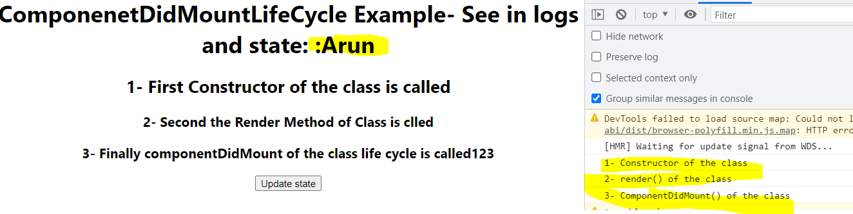

As we know that componentDidMount () will called only once when all the html or Dom is ready to mount these components. And after mounting these components if we perform any activity like state or props update.

To check: Let’s create one state inside the constructor and on the button click update this state.

Now after complete display of the page, if we perform any action like update then only render method will be invoked

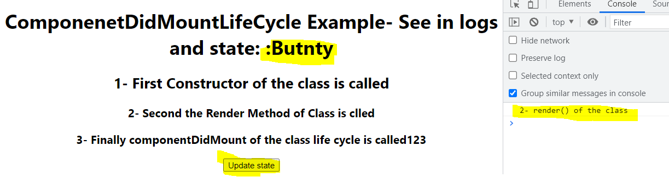

So the componentDidMount will be called only once in the whole life cycle. And this the reason we used to call API inside this method only because we also need to call API only once.

Q; should we update state inside the render () method? Can we update the state in componentDidMount ()?

**ComponentDidUpdate Life cycle method:**

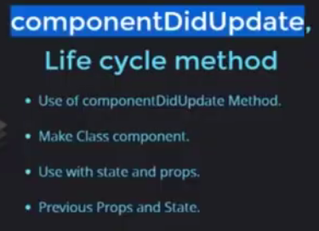



Use of ComponentDidUpdate():

1. As here we can see that the ComponentDidUpdate() gets called whenever we perform and update, even whenever we update any props and state then every time this ComponentDidUpdate method gets called.
2. When we want to perform an event on one state or on every state then this method can be used. **Note**: It is recommended to not to write the code to update any state value here in this method because every time when we perform update event then every time this will update the state and it will form a loop, so in case if we want to update the status value here then we have to do with some conditions.

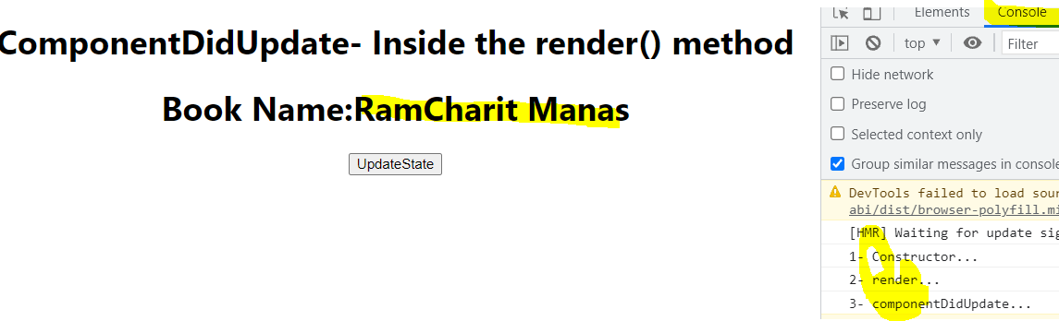

|  |
| --- |
| import React from "react";  class ComponentDidUpdate extends React.Component{      constructor(){          super();          console.log("1- Constructor...");          this.state={              bookname:"RamCharit Manas"          }      }      render(){          console.log("2- render...");          return(              <div>                  <h1>Inside the render() method</h1>                  <h1>Book Name:{this.state.bookname}</h1>                  <button onClick={()=>{this.setState({bookname:"Ramayan"})}}>UpdateState</button>              </div>          );      }      componentDidMount(){          console.log("3- componentDidUpdate...");      }      componentDidUpdate(){          // this.setState({bookname:"Mahabharat"})          console.log("4- componentDidUpdate is called on each update");      }  }  export default ComponentDidUpdate; |

Now let’s click on update and check: .

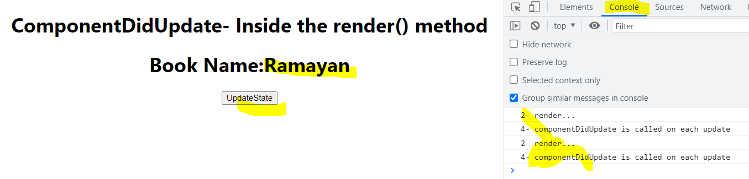

So here we can see that on click on update button only render and componentDidUpdate methods are getting called every time and constructor and componentDidMount() has been called only once.

So the componentDidUpdate() method will be called only on state or props update only.

**Use of previous props and previous state:**

Here we are updating the count state from 0 to one and inside the componentDidUpdate we are checking if preState of count and update state count ==1 then popup alert message.

|  |  |
| --- | --- |
|  |  |

|  |
| --- |
| import React from "react";  class PreStateInComponentDidUpdate extends React.Component{      constructor(){          super();          this.state={              count:0          }      }      render(){          return(              <div>                  <h1>ComponentDidUpdate- Inside the render() method</h1>                  <h1>Count:{this.state.count}</h1>                  <button onClick={()=>{this.setState({count:1})}}>UpdateState</button>              </div>          );      }      componentDidUpdate(preProps,preState,snapshot){          console.warn("componentDidUpdate",preState.count,this.state.count);          if(preState.count===this.state.count){              alert("componentDidUpdate alert message");          }      }  }export default PreStateInComponentDidUpdate; |

**Q:**  Can we stop executing componentDidUpdate():

A: Yes

Q: Should we call the API inside the componentDidUpdate()?

A: If we want to execute API based on some condition then we can use this method otherwise not recommended to call here:

**shouldComponentUpdate Life Cycle Method:**

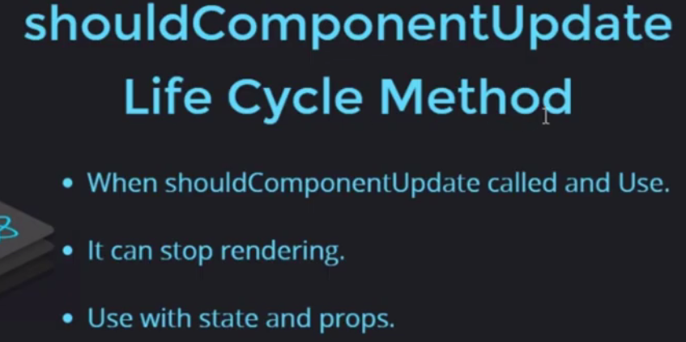

This method plays a very important role in case of performance improvement, this method restricts rendering render() method. If we want to stop rending render() method on any event then we just need to include this method in the class component. By default it returns false value.

But if want to execute render() of the class component with some condition then we just need to return true and render() will execute once condition satisfies.

|  |
| --- |
| import React from "react";  class ShouldComponentUpdateLifeCycleMethod extends React.Component{      constructor(){          super();          console.log("1- Constructor..")          this.state={              count:0          }      }      render(){          console.log("2- Render..")          return(              <div>                  <h1>shouldComponentUpdate Life cycle Method</h1>                  <h2>Counter::{this.state.count}</h2>                  <button onClick={()=>this.setState({count:this.state.count+1})}>Update</button>              </div>          );      }      componentDidMount(){          console.log("3- componentDidMount..")      }      componentDidUpdate(){          console.log("4- componentDidUpdate..")      }      shouldComponentUpdate(){          console.log("5- shouldComponentUpdate.."+ this.state.count)          return false;          //return true;      }  }export default ShouldComponentUpdateLifeCycleMethod; |

Note: Here in the shouldComponentUpdate() we are returning false so after loading if click on update button then in the backend counter value will keep increasing by 1 but render() will not execute and so the updated counter value will not be displayed.

Q: Which method is called first when we click on update button: shouldComponentUpdate() or componentDidUpdate.

A: shouldComponentUpdate() will call first and once it found true then will call componentDidUpdate().

|  |
| --- |
|  |
| So Initially after complete page load constructor(), render() and componentDidMount() is getting called but the componentDidUpdate() and shouldComponentUpdate() method is not getting executed. Now let’s click on the update and see the log. |
| So on clicking on update method only shouldComponentUpdate() method is getting called and in the backend the count value is getting increased by 1. Now let’s return true in shouldComponentUpdate() method. |
| Now in this case first shouldComponentUpdate() then render() and finally componentDidUpdate() methods are getting called on clicking on update button. Hence we can see the updated counter value also. |

**ComponentWillUnmount() Life Cycle Method**

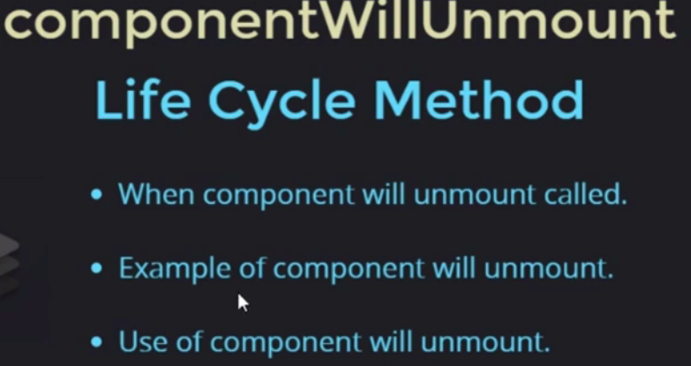



When our component will remove from DOM then this **ComponentWillUnmount** life cycle method will be called.

**Note**: Whenever in react we perform show or hide activity then a complete new cycle starts and this componentDidMount and **ComponentWillUnmount** life cycle method will be called, so it does not mean that show/hide activity is the part of CSS.

|  |
| --- |
| import React from "react";  class ComponentWillUnmountLifeCycle extends React.Component{      constructor(){          super();          console.log ("1- Constructor..");      }      render(){          console.log ("2- render...”);          return(              <div>                  <h1>ComponentWillUnmount Life Cycle Method</h1>              </div>          );      }      componentDidMount(){          console.log ("3- Constructor..");      }      componentWillUnmount(){          console.log ("4- componentWillUnmount..");          alert("componentWillUnmount is called");      }  }export default ComponentWillUnmountLifeCycle; |

**App.js:**

|  |
| --- |
| import ComponentWillUnmountLifeCycle from './ClassLifeCycle/ComponentWillUnmountLifeCycle';  function App() {    const[show,setShow]=React.useState(true);    return (      <div className="App">        {          show? <ComponentWillUnmountLifeCycle />: <h1>Child Component Removed!!</h1>        }        <button onClick={()=>setShow(!show)}>Toggle</button>        </div>    );  }  export default App; |

|  |
| --- |
|  |
|  |
|  |

**ComponentWillUnmount() method is getting called on hiding the element.**

**If we want to stop any running process manually then we can write logic here in this method.**

**Hooks In React JS [useState]**

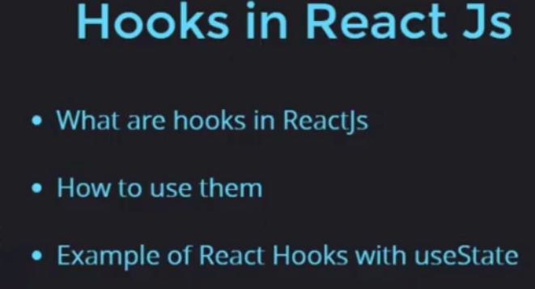

In the last sections we have completed the life cycel methods used in class component, we will start learning life cycle methods used in Functional component and and for that first we will have to know about Hooks.

When we talk about class component then few features are inbuilt features for class component for example: [state, lifecycle methos, pure components etc]

But these inbuilt features are not available for the functional component so with the help of hooks we can use class component features in functional component.

Even thouh we have already used Hooks in the previous sections. Let’s try to understand with one example.

|  |
| --- |
| import React from "react";  function FCLCUsingUseStateHook(){      const [data,setData]= React.useState("Arun");      return(          <div className="Hook">              <h1>Function Component Using- useState Hook!!</h1>              <h2>Name:{data}</h2>              <button onClick={()=>{setData("Bunty")}}>UpdateHook</button>          </div>      );  }export default FCLCUsingUseStateHook; |

1. Here, useState is a *Hook*. We call it inside a function component to add some local state to it. React will preserve this state between re-renders. useState returns a pair: the *current* state value and a function that lets you update it. We can call this function from an event handler or somewhere else. It’s similar to **this.setState** in a class, except it doesn’t merge the old and new state together.
2. Using Hooks we can write class component life cycle method method in functional component
3. *Hooks* are a new addition in React 16.8. They let you use state and other React features without writing a class.
4. ***Note****:* ***All the hooks in the functional component start with ‘use’***

**Declaring multiple state variables**

|  |
| --- |
| function ExampleWithManyStates() {  // Declare multiple state variables!  const [age, setAge] = useState(42);  const [fruit, setFruit] = useState('banana');  const [todos, setTodos] = useState([{ text: 'Learn Hooks' }]);    } |

**Rules of Hooks**

Hooks are JavaScript functions, but they impose two additional rules:

Only call Hooks at the top level. Don’t call Hooks inside loops, conditions, or nested functions.

Only call Hooks from React function components. Don’t call Hooks from regular JavaScript functions

Q: Can we use Hooks in the class component?

A: No

**Effect Hook**

1. As we have used the different life cycle methods like [componentDidMount, componentDidUpdate, and componentWillUnmount] , so to achieve these life cycle method’s features in the functional Component we can use Effect Hook(useEffect) i.e.
2. It serves the same purpose as componentDidMount, componentDidUpdate, and componentWillUnmount in React classes, but unified into a single API.
3. We can think of useEffect Hook as componentDidMount, componentDidUpdate, and componentWillUnmount combined.
4. We can achieve all the class component life cycle method feature using useEffect only just by using different conditions according to requirments.

|  |
| --- |
| import React from "react";  function UseEffectHookUse(){  const[data,setData]= React.useState(0); // declaring hook useState  React.useEffect(()=>{ // declaring hook useEffect      console.log("Inside useEffect-1");  });  // We can declare multiple useEffect hook  React.useEffect(()=>{      console.log("Inside useEffect-2");  });      return(          <div class="App">              <h1>UseEffectHookUse::Counter::{data}</h1>              <button onClick={()=>setData(data+1)}>update counter</button>          </div>      );  }export default UseEffectHookUse; |

**Created two hooks: useState and useEffect**

* const[data,setData]= React.useState(0);
* React.useEffect(()=>{ // Write the logic });

Now let’s run the above program and see the effect.

|  |
| --- |
|  |

Now when the pages gets loaded completely then we found that the log written both the useEffect got executed sequencelly. So this can be considered as **componentDidMount()** life cycle method of the class component which gets executed once page gets loaded. No let’s click on update button and check.

|  |
| --- |
|  |

As we can see that we have clicked update button two times and counter get updated from 0 to 2 and we can see that everty time both the **useEffect()** methods gets executed. It is very similar to **componentDidUpdate()** method life cycle of class component. So we can conclude that useEffect() method can used for [**componentDidMount , componentDidUpdate**] . These multiple useEffect() can be used for different requirment based on conditions.

Q: Can we define function inside the useEffect and vice-versa?

**useEffect with Specific state and Props:**

 Here we will see that how we can call the useEffect with specific state or props. For example let’s say we have 5 state or props and if we want to call useEffect for three state or props and for remaining 2 state or props it could not be invoked then how we will achieve?

|  |
| --- |
| import React, { useEffect } from "react";  function UseEffectHookWithStateAndProps(props){      const[num1,setNum1]=React.useState(0);      const[num2,setNum2]=React.useState(100);      useEffect(()=>{          console.log("useEffect from state- num1::"+num1);      },[num1]);      useEffect(()=>{          console.log("useEffect from state- num2::"+num2);      },[num2]);      useEffect(()=>{          console.log("useEffect from state- propsNum::"+props.numProps);      },[props.numProps]);      return(          <div className="App">              <h1>UseEffectHookWithStateAndProps::</h1>              <h2>Num1: {num1}</h2>              <h2>Num2: {num2}</h2>              <h2>Num3: {props.numProps}</h2>              <button onClick={()=>{setNum1(num1+1)}}>UpdateStateNum1</button>              <button onClick={()=>{setNum2(num2+1)}}>UpdateStateNum2</button>          </div>      );  }export default UseEffectHookWithStateAndProps; |

1. Created two useState with default values(0) and (100)
2. Created two buttons to update these states on click event.
3. Created three useEffect Hooks. Now if want to execute these useEffect on particular state and props then to achieve that we have provided as array parameter in each useEffect Hook method.
4. As here we can see that in the first useEffect hook method I have passed num1 so this method will be invoke for state num1. Similarly we have passed state num2 and props numProps. Now these three useEffect will work for both componentDidMount() and componentDidUpdate() life cycle method of the class component inside the functional component.

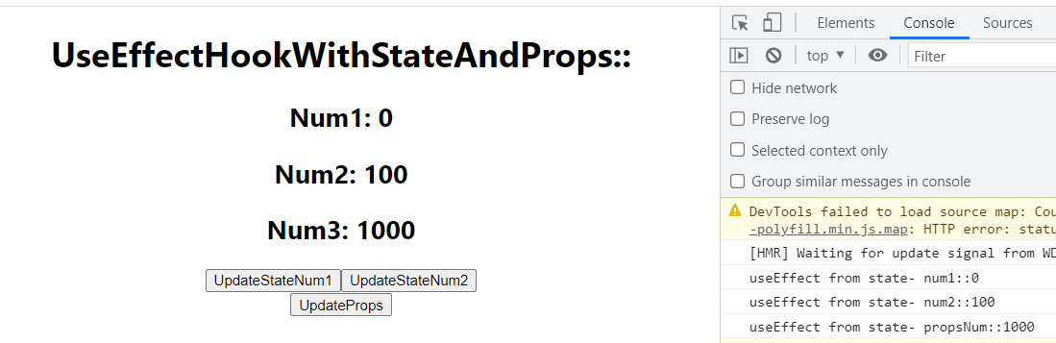

So on the page load all the three useEffect hooks are getting called just like componentDidMount of the class LC method.

Now let’s check on each button click.

|  |
| --- |
|  |
| Clicked on button one and so num1 updated from 0 to 1 and only its useEffect hook method got called and we can see the log of useEffect hook method where state num1 is passed and it is similar to componentDidUpdate of Class comp. |
|  |
| Now on clicking on second button only second useEffect hook method got called and number updated from 100 to 101 and only this useEffect hook method log got printed |
|  |
| Now finally when clicked on UpdateProps button then only the useEffect hook method gets called which was assigned for prop and only this useEffect log got printed. |

Hence we can invoke the useEffect hook method accrding to states and props of the functional component

: We can pass all the states and props in any of the useEffect hook method and in this case it will be invoked for all the states and props.

|  |
| --- |
| useEffect(()=>{          console.log("useEffect from state- propsNum::"+props.numProps+num1+num2);      },[num1,num2,props.numProps]); |

**Now this particular useEffect hook method will be invoked for all the states and props.**

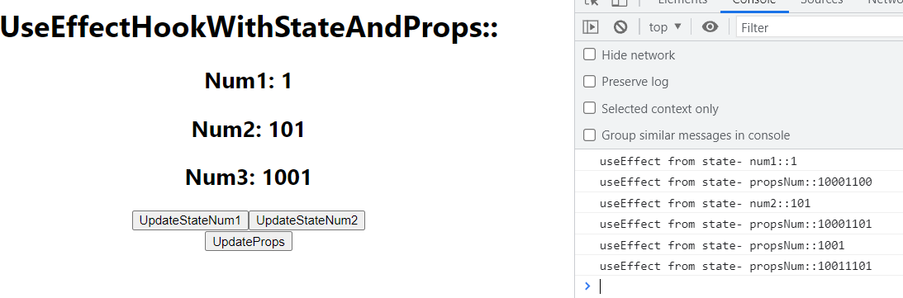

Q: Can we use – useEffect inside useEffect. Ans: Yes

**Style Type in React Js**

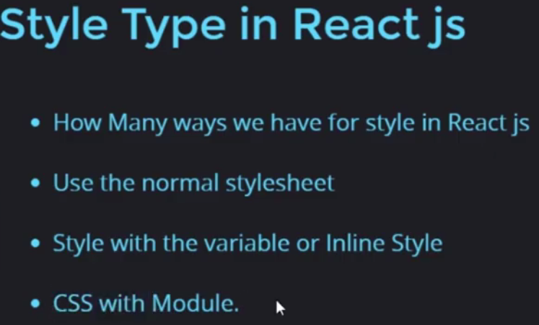

Basically we can have three type of CSS styling in the React Js

1. Normal StyleSheet
2. Variable or Inline style
3. CSS with Module

|  |
| --- |
| import React from "react";  import './App.css';  import './ReactStyleCSS/style.css';  import style from './ReactStyleCSS/custom.module.css'  function StyleTypeInReact() {      return (          <div className="App">            <h1 className="primary">This is the style type in React Js using normal style css file</h1>              <div style={{color:'red',backgroundColor:"black"}}>                  <h1>This is the in line CSS style</h1>              </div>              <h1 className={style.sucess}> This the style from CSS With module</h1>          </div>      );  } export default StyleTypeInReact; |

Let’s wrtie the CSS

|  |  |
| --- | --- |
| Normal style.css | .primary{      background-color: black;      color: yellow;  } |

**Inline CSS**

|  |
| --- |
| **Inline CSS**: syntax: style={{write CSS here}} i.e. inside two curly braces first {} is for JSX and anothr {} is for CSS  Example:  **<div style={{color:'red',backgroundColor:"black"}}>** |

**CSS With Module:**

|  |
| --- |
| To create file for CSS with module is [filename.module.css] i.e. we need to mention module with file name   1. And we need to import into js file   **import style from './ReactStyleCSS/custom.module.css'**   1. **Now to access the className of module css file**   **<h1 className={style.sucess}> This the style from CSS With module</h1>** |

**Install Bootstrap in React JS:**



4.33.46

Bootstrap is basically nothing but the library which contains css and js files, which helps in providing responsive web pages. It provides the readymade setup like [buttons, grid etc] for designing stylish web pages.

**How to install Bootstrap in React Js:**

**Handle Array with List:**



1. How to handle array
2. How to display List in React JS

|  |
| --- |
| import React from "react";  function UsingMapAndForLoop(){      const students=['Arun','Bunty','Junty','Atharv','Tarun'];      const myColor=['Green','Yellow','Red','White','Brown'];      // map looping      students.map((item)=>{          console.log("Student Name is from Map:",item);      });      // for Loop can be used outside of return method but cannot be used inside return() method      for(let i=0;i<students.length;i++){          console.log("Name using for loop:",students[i]);      }      return(          <div className="App">              <h1>Handle Array with Map</h1>              { **// Convert the myColor list into map and then print their values**                  myColor.map((data)=>                      <h2>Color Nameis ::{data}</h2>                  )              }              {                  for(let i=0; myColor.length;i++){                      <h2>Color Nameis ::{myColor[i]}</h2>                  }              }          </div>      );  }export default UsingMapAndForLoop; |
|  |

So we can see that for not allowed inside the return () function and we cannot write for loop in between html tag. But we can use map inside the return () function and in between html tag. That is why we use map function not for loop for iterating the list element in React.

**Handling Map with Multiple List Objects: importing Table from Bootstrap**

|  |
| --- |
| import React from "react";  function HandlingMapWithMultipleListObjects() {      const students = [          { name: "Arun", email: "imarungupta@gmail.com", contact: 11236 },          { name: "TArun", email: "imtarungupta@gmail.com", contact: 1111 },          { name: "VArun", email: "imvarungupta@gmail.com", contact: 2222 },          { name: "GArun", email: "imgarungupta@gmail.com", contact: 3333 }      ];      students.map((item) => {          console.log("Name:", item.name + " email:", item.email + " Contact:", item.contact);      })      return (          <div className="App">              <h1>This is my HandlingMapWithMultipleListObjects</h1>              <h3>Looping student list using map inside return and div tag</h3>              <table border="1">                  <tr>                      <td>Name</td>                      <td>Email</td>                      <td>Contact</td>                  </tr>                  {                      students.map((item) =>                          <tr>                              <td>{item.name}</td>                              <td>{item.email}</td>                              <td>{item.contact}</td>                          </tr>                      )                  }              </table>          </div>      );  } export default HandlingMapWithMultipleListObjects; |

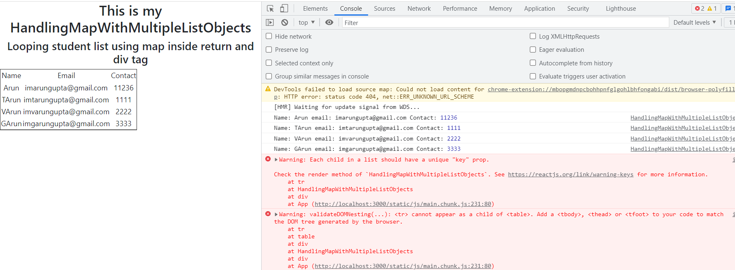

We are getting proper output but getting warning:

index.js:1 Warning: Each child in a list should have a unique "key" prop. Because for each row it expect key just to create be identified by virtual DOM

That is why we have provided key inside the map and same key we have given inside the <tr>

Another warning we are getting because child of the table i.e. <tr> should be inside <tbody>

So final code is given as:

|  |
| --- |
| import React from "react";  function HandlingMapWithMultipleListObjects() {      const students = [          { name: "Arun", email: "imarungupta@gmail.com", contact: 11236 },          { name: "TArun", email: "imtarungupta@gmail.com", contact: 1111 },          { name: "VArun", email: "imvarungupta@gmail.com", contact: 2222 },          { name: "GArun", email: "imgarungupta@gmail.com", contact: 3333 }      ];      students.map((item) => {          console.log("Name:", item.name + " email:", item.email + " Contact:", item.contact);      })      return (          <div className="App">              <h1>This is my HandlingMapWithMultipleListObjects</h1>              <h3>Looping student list using map inside return and div tag</h3>              <table border="2">                  <tbody>                  <tr border="1">                      <td>Name</td>                      <td>Email</td>                      <td>Contact</td>                  </tr>                  {                      students.map((item ,keyValue) =>                          <tr key={keyValue}>                              <td>{item.name}</td>                              <td>{item.email}</td>                              <td>{item.contact}</td>                          </tr>                      )                  }                  </tbody>              </table>          </div>      );  } export default HandlingMapWithMultipleListObjects; |

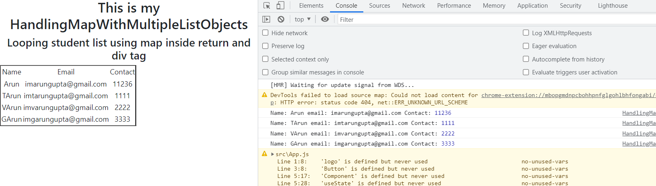

Now let’s try to show the table using bootstrap:

1. First we have to import [import {Table} from 'react-bootstrap';
2. Now instead of <table></table> we just need to replace small (t) with capital (T)
3. Now let’s run the above program and see the magic

<https://react-bootstrap.github.io/components/table/>

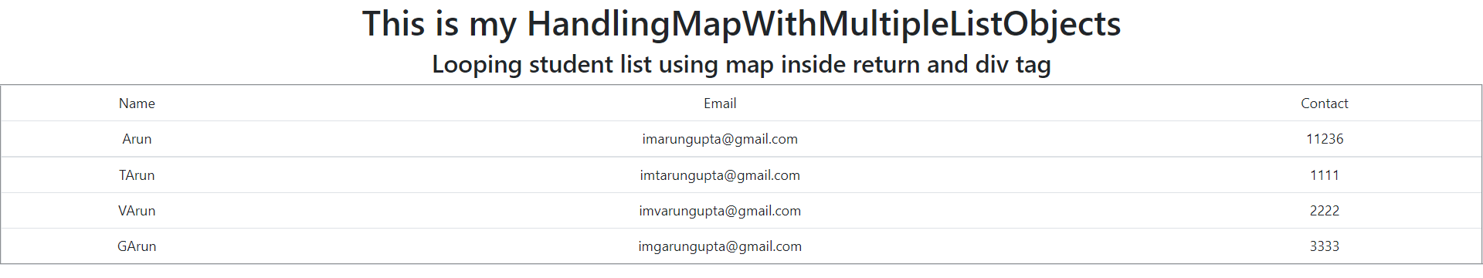

So we have got the table in the proper format:

 <Table border="1" striped bordered hover size="sm" variant="dark" responsive > </Table>

Now we can see the table content in striped border , small size and dark

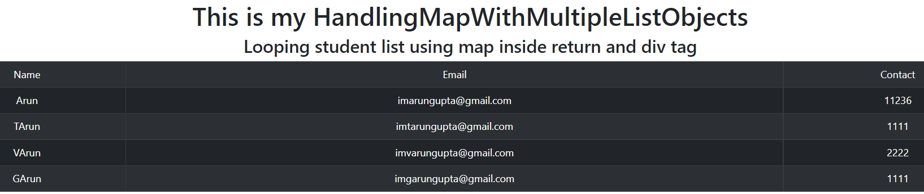

So in the above example we have used the table from the bootstrap.

Q: Now let’s say if we want to display the row from the table which contact number is 1111?

A: We can use ternary operation on the **item. Contact**

**If (item.contact)===1111? Then show the table row : show Null**

|  |
| --- |
| <Table border="1" striped bordered hover size="bg" variant="dark" responsive >                  <tbody>                  <tr border="1">                      <td>Name</td>                      <td>Email</td>                      <td>Contact</td>                  </tr>                  {                      students.map((item ,key) =>                      item.contact===1111?                          <tr key={key}>                              <td>{item.name}</td>                              <td>{item.email}</td>                              <td>{item.contact}</td>                          </tr> : null                      )                  }                  </tbody>  </Table> |



Q: How we can show the serial number in above table?

**Nested List with Nested Array:**



How to show nested list from Nested Array?

1. First let’s create the nested Array where one name will have multiple address

|  |
| --- |
| const students=[          { name: "Arun", email: "imarungupta@gmail.com", contact: 11236, address:[              {HN:"10", city:"BRL", State:"KA"},              {HN:"11", city:"DEL", State:"NCR"},              {HN:"12", city:"KOL", State:"WB"},              {HN:"13", city:"ALD", State:"UP"}          ]},          { name: "TArun", email: "imtarungupta@gmail.com", contact: 1111, address:[              {HN:"14", city:"BRL1", State:"KA1"},              {HN:"15", city:"DEL1", State:"NCR1"},              {HN:"16", city:"KOL1", State:"WB1"},              {HN:"17", city:"ALD1", State:"UP1"}          ]},          { name: "VArun", email: "imvarungupta@gmail.com", contact: 2222, address:[              {HN:"18", city:"BRL2", State:"KA2"},              {HN:"19", city:"DEL2", State:"NCR2"},              {HN:"20", city:"KOL2", State:"WB2"},              {HN:"21", city:"ALD2", State:"UP2"}          ]},          { name: "GArun", email: "imgarungupta@gmail.com", contact: 1111, address:[              {HN:"22", city:"BRL3", State:"KA3"},              {HN:"23", city:"DEL3", State:"NCR3"},              {HN:"24", city:"KOL3", State:"WB3"},              {HN:"25", city:"ALD3", State:"UP3"}          ]}      ] |

Here first of all created one list having name, email, contact and address and further we have created one nested list having multiple address in the list. This way we can create nested list.

1. Now let’s display this nested list inside return() method

|  |
| --- |
| return(          <div className="App">              <h1>Displaying Nested List::</h1>              <Table variant="dark" striped > // Outer table for showing complete list values                  <tbody>                      <tr>                          <td>Sr.No</td>                          <td>Name</td>                          <td>Email</td>                          <td>Contact</td>                          <td>Address</td>                      </tr>      {                      students.map((item,i)=>                      <tr key={i}>                           <td>{i+1}</td> // To print serial number based on key                          <td>{item.name}</td>                          <td>{item.email}</td>                          <td>{item.contact}</td>                          <td>    <Table variant="dark" striped bordered hover> // Inner table for add display                              <tbody>                              {                                  item.address.map((add)=> // Created one map for address list                                  <tr>                                  <td>{add.HN}</td>                                  <td>{add.city}</td>                                  <td>{add.State}</td>                                  </tr>                                  )                              }                              </tbody>                           </Table>                          </td>                      </tr>                        )                  }                  </tbody>              </Table>          </div>      ); |

So here for displaying nested loop values

1. Created the map for first map and display its values using outer <Table>
2. Further to show the nested list address, created map of address and then display its values using inner <Table>

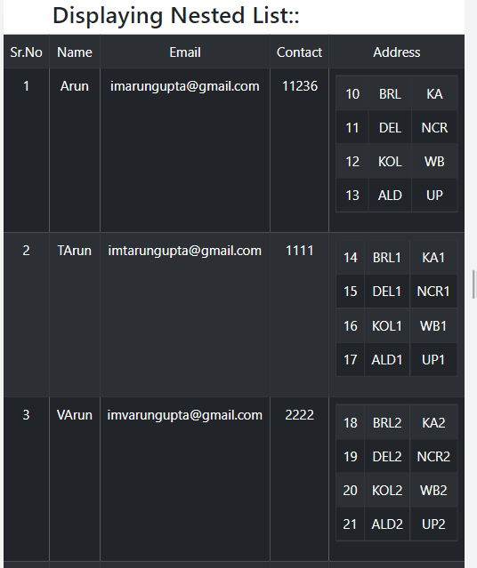

Complete Code:

|  |
| --- |
| import React from "react";  import {Table} from 'react-bootstrap';  function NestedArrayListHandleWithMap(){      const students=[          { name: "Arun", email: "imarungupta@gmail.com", contact: 11236, address:[              {HN:"10", city:"BRL", State:"KA"},              {HN:"11", city:"DEL", State:"NCR"},              {HN:"12", city:"KOL", State:"WB"},              {HN:"13", city:"ALD", State:"UP"}          ]},          { name: "TArun", email: "imtarungupta@gmail.com", contact: 1111, address:[              {HN:"14", city:"BRL1", State:"KA1"},              {HN:"15", city:"DEL1", State:"NCR1"},              {HN:"16", city:"KOL1", State:"WB1"},              {HN:"17", city:"ALD1", State:"UP1"}          ] },          { name: "VArun", email: "imvarungupta@gmail.com", contact: 2222, address:[              {HN:"18", city:"BRL2", State:"KA2"},              {HN:"19", city:"DEL2", State:"NCR2"},              {HN:"20", city:"KOL2", State:"WB2"},              {HN:"21", city:"ALD2", State:"UP2"}          ] },          { name: "GArun", email: "imgarungupta@gmail.com", contact: 1111, address:[              {HN:"22", city:"BRL3", State:"KA3"},              {HN:"23", city:"DEL3", State:"NCR3"},              {HN:"24", city:"KOL3", State:"WB3"},              {HN:"25", city:"ALD3", State:"UP3"}          ] }      ];      return(          <div className="App">              <h1>Displaying Nested List::</h1>              <Table variant="dark" striped >                  <tbody>                      <tr>                          <td>Sr.No</td>                          <td>Name</td>                          <td>Email</td>                          <td>Contact</td>                          <td>Address</td>                      </tr>                    {                        students.map((item,i)=>                      <tr key={i}>                           <td>{i+1}</td>                          <td>{item.name}</td>                          <td>{item.email}</td>                          <td>{item.contact}</td>                          <td>                          <Table variant="dark" striped bordered hover>                              <tbody>                              {                                  item.address.map((add)=>                                  <tr>                                  <td>{add.HN}</td>                                  <td>{add.city}</td>                                  <td>{add.State}</td>                                  </tr>                                  )                              }                              </tbody>                           </Table>                          </td>                      </tr>                        )                  }                  </tbody>              </Table>          </div>      );  }export default NestedArrayListHandleWithMap; |

**Reusing Component:**



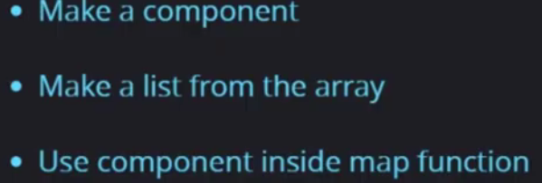

* As we know that the primary purpose of creating component so that it can be re-used where ever it required. Here we will try to know how we can re-use the component.
* As in the last videos we have seen that how we can make list from array and basically for that we have used map () function and inside this map we have <Table> and we have rendered the list here inside <Table>
* Now here we will use component at the place of <Table> and will see that how we can reuse because if it gets renders multiple time then it means we are reusing.
* The advantage of reusing component multiple times is that we can get to that how the component behaves inside the loop and then we can get to know that how we can pass props inside the component in the loop.

|  |
| --- |
| import React from "react";  import ReuseAddressComponent from "./ReuseAddressComponent";  import ReuseUserComponent from './ReuseUserComponent';  function UsersWhereToReuseUserComponent(){      const Users=[          { name: "Arun", email: "imarungupta@gmail.com", contact: 11236, address:[              {HN:"10", city:"BRL", State:"KA"},              {HN:"11", city:"DEL", State:"NCR"},              {HN:"12", city:"KOL", State:"WB"},              {HN:"13", city:"ALD", State:"UP"}]          },          { name: "TArun", email: "imtarungupta@gmail.com", contact: 1111, address:[              {HN:"10", city:"BRL", State:"KA"},              {HN:"11", city:"DEL", State:"NCR"},              {HN:"12", city:"KOL", State:"WB"},              {HN:"13", city:"ALD", State:"UP"}] },          { name: "VArun", email: "imvarungupta@gmail.com", contact: 2222, address:[              {HN:"10", city:"BRL", State:"KA"},              {HN:"11", city:"DEL", State:"NCR"},              {HN:"12", city:"KOL", State:"WB"},              {HN:"13", city:"ALD", State:"UP"}] },          { name: "GArun", email: "imgarungupta@gmail.com", contact: 1111, address:[              {HN:"10", city:"BRL", State:"KA"},              {HN:"11", city:"DEL", State:"NCR"},              {HN:"12", city:"KOL", State:"WB"},              {HN:"13", city:"ALD", State:"UP"}]          }      ];      return(          <div>              <h1>Reuse Function component having nested list:</h1>              {                  Users.map((item)=>                  <ReuseUserComponent data={item}/>                  )              }          </div>      );  }export default UsersWhereToReuseUserComponent; |

Here convert the Users list into map and passing this map to the <ReuseUserComponent data= {item}/> as props. Now this props will be used inside the ReuseUserComponent component to extract the Users data.

Let’s create the ReuseUserComponent.js and extract the Users List values.

|  |
| --- |
| import React from "react";  import {Table} from 'react-bootstrap';  import ReuseAddressComponent from "./ReuseAddressComponent";  function ReuseUserComponent(props){      return(          <div className="App">              <Table variant="dark" striped bordered hover>                  <tbody>                  <tr>                      <td>Name</td>                      <td>Email</td>                      <td>Contact</td>                      <td>Address</td>                  </tr>                  <tr>                      <td>{props.data.name}</td>                      <td>{props.data.email}</td>                      <td>{props.data.contact}</td>                      <td>                          {                              props.data.address.map((i)=>                              <ReuseAddressComponent addKey={i}/>                              )                          }                      </td>                  </tr>                  </tbody>              </Table>          </div>      );  }export default ReuseUserComponent; |

1. Here we can see that using props.data we are accessing the Users list values [name,email,contract]
2. Since in the Users list address is the nested list so to extract address list first access the address using [props.data.address] and then convert this into map and then further sent to <ReuseAddressComponent addKey={i}/> as props so that inside ReuseAddressComponent component we can access the address values.

Let’s create ReuseAddressComponent.js component

|  |
| --- |
| import React from "react";  import {Table} from 'react-bootstrap';  function ReuseAddressComponent(props) {      return (          <Table variant="dark" striped bordered hover>              <tbody>                  <tr>                      <td>HN</td>                      <td>City</td>                      <td>State</td>                  </tr>                  <tr>                      <td>{props.addKey.HN}</td>                      <td>{props.addKey.city}</td>                      <td>{props.addKey.State}</td>                  </tr>              </tbody>          </Table>      );  }export default ReuseAddressComponent; |

Now here using props we are accessing the address values.

So in this way we can create reusable component and can be used according to need this reusable component contain all the things like css, html, values ready to use.

Output:

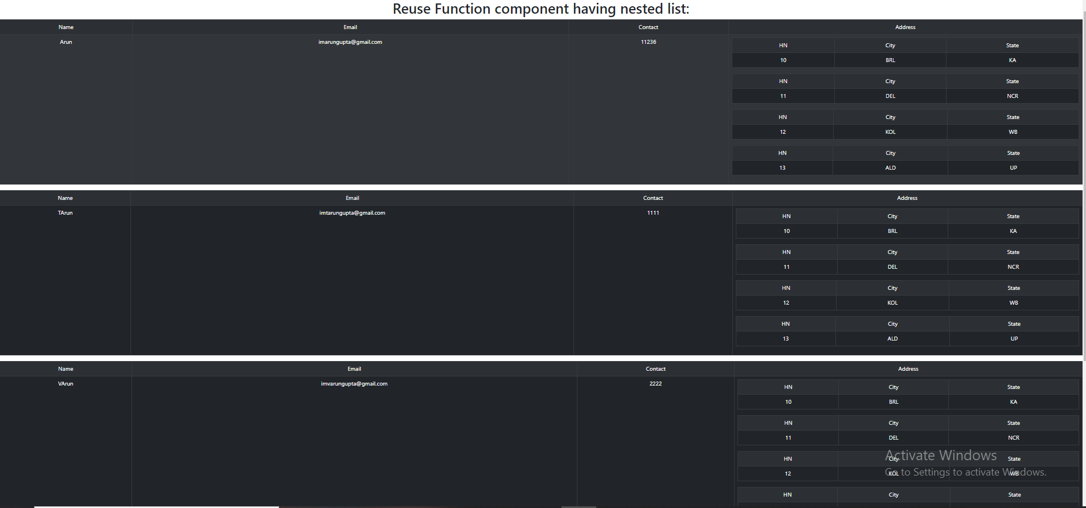

|  |  |
| --- | --- |
| **React Fragment** |  |

**What is React Fragment? And how to use it?**

**Use it with child component?**

A common pattern in React is for a component to return multiple elements. Fragments let you group a list of children without adding extra nodes to the DOM. i.e.

When we write component then inside the return () we used to write multiple html element node. Usually when we want to write the multiple html tag then we used write inside <div> tag, without <div> we cannot write multiple html tag inside return () function. In the same way we can use react fragment for multiple tag elements or component.

So in sort fragment is nothing but small container where we can have multiple children or element

|  |  |
| --- | --- |
| render() {  return (  <div>  <ChildA />  <ChildB />  <ChildC />  </div>  );  }  Return using normal <div> container | render() {  return (  <React.Fragment>  <ChildA />  <ChildB />  <ChildC />  </React.Fragment>  );  }  Return using normal < React.Fragment > container |

1. We can use multiple <div> inner tag but we cannot use several independent <div> tag inside the return()
2. Similarly for <React.Fragment>
3. We can write only one tag or element without <div> or <React.Fragment> . But if we want to write multiple tag then we have write inside <div> or <React.Fragment> element only.

|  |  |
| --- | --- |
| import React from "react";  **Example having <div> tag as well as fragment tag>** | |
| function ReactFragmentUse(){      function UseDiv(){          return(              <div>                  <h1>reutrn using div container1</h1>                  <h1>reutrn using div container2</h1>              </div>              )      }      return(            <React.Fragment>              <UseDiv />              <h1>reutrn using Fragment container1</h1>              <h1>reutrn using Fragment container2</h1>          </React.Fragment>      );  }export default ReactFragmentUse; | Output:    Without <div> tag: |

So we can see that without <div> if we write multiple html element tag then It is not allowing and we are getting error. And saying JSX expressions must have one parent element.

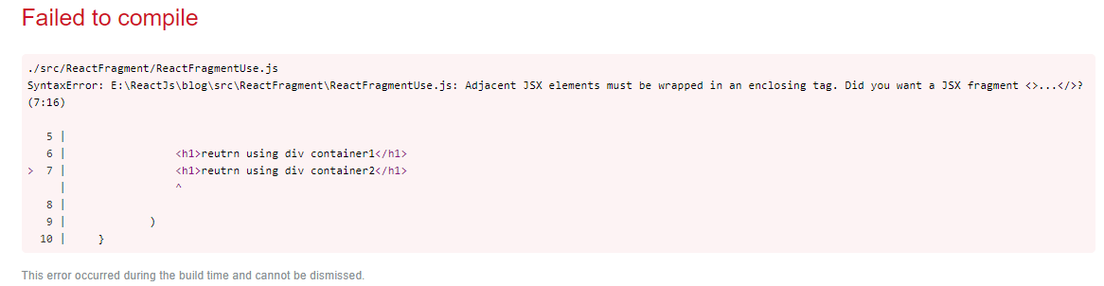

Note: if we use empty tag <> </> then also it will work as parent container for multiple element and code will work:

|  |
| --- |
| function UseEmptyTag(){          return(             <>                  <h1>reutrn using div container1</h1>                  <h1>reutrn using div container2</h1>             </>              )      } |

This is another way to use react fragment using empty tag.

Example: Create on functional component where we will take <table> element and let’s create another functional component Col() where let’s return two html element inside return () in the <div> tag.

|  |  |
| --- | --- |
| import React from "react";  function Col(){      return(        <div>          <td>Arun</td>          <td>Gupta</td>      </div>      );  }export default Col; | import React from "react";  import Col from './Col';  function ReactFragmentInsideTable(){      return(          <div>              <table>                  <tbody>                      <tr>                          <Col />                      </tr>                  </tbody>              </table>          </div>      );  }export default ReactFragmentInsideTable; |

|  |  |
| --- | --- |
|  |  |

So here when we call the functional component Col() inside ReactFragmentInsideTable() then we get warning that <div> tag cannot appear as child , so in this case we can use react fragment. Let’s use

|  |  |
| --- | --- |
| import React from "react";  function ColWithReactFragment(){      return(        <React.Fragment>          <td>Arun</td>          <td>Gupta</td>      </React.Fragment>      );  }export default  ColWithReactFragment; | import React from "react";  **import ColWithReactFragment from "./ColWithReactFragment";**  function ReactFragmentInsideTable(){      return(          <div>              <table>                  <tbody>                      <tr>  **<ColWithReactFragment />**                      </tr>                  </tbody>              </table>          </div>      );  }export default ReactFragmentInsideTable; |

Now in this case ColWithReactFragment() contains the <td> tag inside fragment and now the same component we are using in another component and in this case we don’t get any warning.

So this is the main advantage of using react fragment.

**Lifting State Up : OR Send Data Child to Parent Component:**



**Child component App.js**

|  |
| --- |
| import React from "react";  function ParentToChildAndChildToParent(props){      const name="Arun Gupta";      return(          <div>              <h1>This is my Child component</h1>              <h1>Receving data from parent to child: {props.data}</h1>              <button onClick={()=>props.method(name)}>Click Me</button>          </div>      );  }export default ParentToChildAndChildToParent; |

Now let call this function in the parent component App.js

|  |
| --- |
| function App() {    const [numProps, setNumProps] = React.useState(1000);    function ParentFunction(name){      console.log("This is parent function",name);      alert(name);    }    return (      <div className="App">        <ParentToChildAndChildToParent data={numProps} method={ParentFunction}/>      </div>    );  }export default App; |

1. Created one const with useState (1000)
2. Now Called the child function ParentToChildAndChildToParent and passed numProps useState as props
3. At the side of child component receive this numProps using {props.data}

So this is the Lisfting stat from parent to child

Liftingup from child to parent:

1. Created on inner functionin the parent component with name ParentFunction(name) and pass this as a props inside the child method calling tag
2. At the child component created on const variable ‘name’
3. Finally call the parent function component in the child component and during call pass the name as function parameter
4. Now when we click on the button then Parent function method gets called and the child const name goes to parent component function.

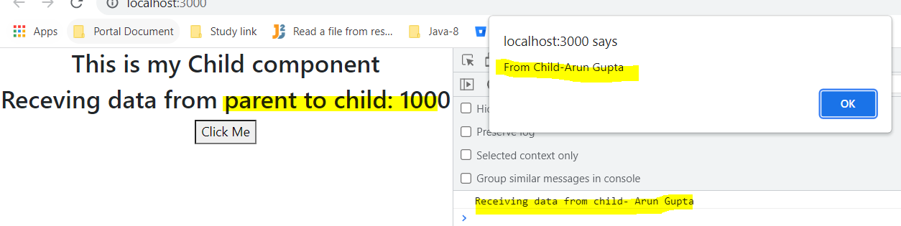

So this way we have achieved parent to child and child to parent data sending process.

**Pure Component:**



1. It is nothing but a feature in the react js, which we have to import and use it in the component.
2. This feature can be used with the Class component, for the functional component we will one feature called memo (Hook)
3. Pure component help in stopping re-rending of the component i.e. stops executing unnecessary for several times
4. Let’s say we have sent one name “Arun” in the Class state and on the button click same name we are setting again and again then each time when we click the button then every time our component will be re-rendered just to check the latest status update of the state. So the pure component before rendering will check that the previous state and current state are same or not. If it is same then it does not allow the re-render and if both are different then only it will allow to re-render.

Let’s create one class component where we will update the state on button click so in this case whenever a new state comes the render() method of the class will be called.

|  |
| --- |
| import React from "react";  class PureClassComponent extends React.Component{      constructor(){          super();          this.state={              count:1          }      }      render(){          console.warn("Pure Component render method is called");          return(              <div>                  <h1>This is my Pure Class Component!!:: {this.state.count}</h1>                  <button onClick={()=>this.setState({count:this.state.count+1})}>Update</button>              </div>          )      }  }export default PureClassComponent; |

Output:

|  |
| --- |
|  |
| Now let’s click on the update and check the log. |

So each time whenever the state gets updated then render () method of the class is also gets called.

Now let’s take one scenario where the state is not getting updated so in this case render method should not be called but even though we are not updating state, the render() will be called every time while it is not required.

|  |
| --- |
| import React from "react";  class PureClassComponent extends React.Component{      constructor(){          super();          this.state={              count:1          }      }      render(){          console.warn("Pure Component render method is called");          return(              <div>                  <h1>This is my Pure Class Component!!:: {this.state.count}</h1>                  <button onClick={()=>this.setState({count:1})}>Update</button>              </div>          )      }  }export default PureClassComponent; |

So in the above example we have set constant value in the state which is 1 and we are not updating its value on each button click.

|  |
| --- |
|  |

So we can see that even though we have not updating the state but the render() method is getting executed on button click so here it not required to re-render the render() method at all because it is getting rendered unnecessary. So to stop unnecessary rendering we will extends pure component instead of extending normal component.

|  |
| --- |
| import React from "react";  class PureClassComponent extends React.PureComponent{      constructor(){          super();          this.state={              count:1          }      }      render(){          console.warn("Pure Component render method is called");          return(              <div>                  <h1>This is my Pure Class Component!!:: {this.state.count}</h1>                  <button onClick={()=>this.setState({count:1})}>Update</button>  **{/* <button onClick={()=>this.setState({count:this.state.count+1})}>Update</button> */}**              </div>          )      }  }export default PureClassComponent; |

So we have just extends PureComponent and now it will not allow to execute

|  |
| --- |
|  |
| But if we uncomment the below button line and then run then on each button click state will be update and in this case render method will be called every time. |

So in this way we can prevent unnecessary rendering of the render method of the class and thus it will increase the performance of the application.

**useMemo Hook in React Js**

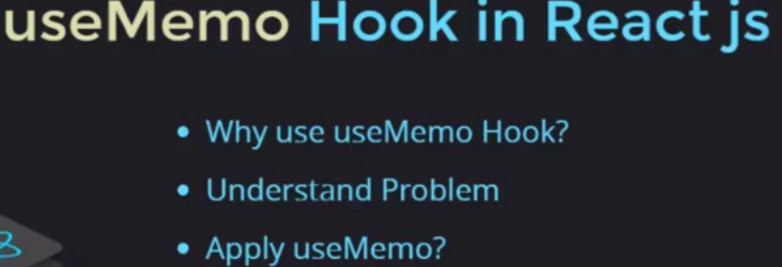

This is very similar to pureComponent of the class component to stop unnecessary rending of the render method. In the same way in the functional if want to stop unnecessary rendering of the render() method of the functional component then we will use useMemo Hook. i.e.

PureComponent is for class based component and useMemo is for function based component. But both have same work just to enhance the performance of the application. Only both have different ways to use. In class based component we just need to extend in the class. But useMemo has different ways to use in function based component.

Let’s see how?

|  |
| --- |
| import React from "react";  function UseMemoHook() {      const [num1, setNum1] = React.useState(1);      const [num2, setNum2] = React.useState(10);      // function multiCount(){      //     return num1*5;      // }      const multiCountMemo = React.useMemo(          function multiCount() {               console.warn("multifunction - ",num1*5);              return num1 * 5;          },[num1])      return (          <div>              <h1>This is useMemo Hook</h1>              <h2>First Num1::{num1}</h2>              <h2>Second Num2::{num2}</h2>              <h2>multiCount:num1*5: {multiCountMemo}</h2>              <button onClick={() => setNum1(num1 + 1)}>Update First</button>              <button onClick={() => setNum2(num2 + 1)}>Update First</button>          </div>      );  } export default UseMemoHook; |

Here in above program if we uncomment the above method multicount () then it will be called on each click which it should be called for num1 only but it would be called for num2 also.

|  |
| --- |
|  |

So to prevent this we have used useMemo Hook and kept the multicount () function inside this hook and put num1 as parameter inside this useMemo hook function, which specifies that this useMemo function would be called only for num1 useState otherwise it would never be called.

|  |
| --- |
|  |

Now here we can see that when update first button which is associated with num1 is clicked then only multifunction () method is called and for the second button update second which is associated with num2 is called then this multifunction () never gets called.

So in this way we can prevent executing unnecessary method and can enhance the performance.

**Ref in React JS**

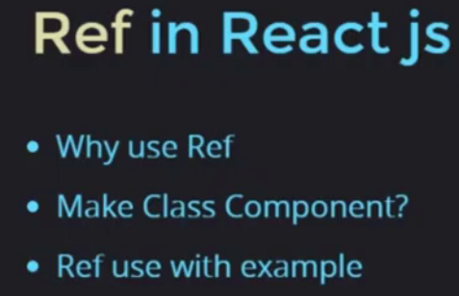

1. Ref basically used to manipulate the DOM which is not recommended to use.
2. Using Ref we can do several action like [hide and show] , changing background color
3. But React says do not use Ref until it is very-2 necessary and always recommend to use states and props only for all the activities.
4. For example when we create form then we have to do lot of things like messages showing, validation etc so in this case we can use Ref
5. Ref basically can be used with class component easily, it is not easy to use with function component

|  |
| --- |
| import React,{createRef} from "react";  class RefInReactJs extends React.Component{      constructor(){          super();          this.inputRef=React.createRef(); // Now this inputRef can be used anywhere to manipulate DOM      }      componentDidMount(){          //setting the value in the text box          this.inputRef.current.value="1000";        }      getValue() { // when this method will be called then input value color will become in red          console.warn("Input Value is:"+ this.inputRef.current.value);          this.inputRef.current.style.color="red";      }      render(){          return(              <div>                  <h1>Ref In React JS</h1>                  <input type="text" ref={this.inputRef}/> // passing the inputRef to manipulate input text                  <button onClick={()=>this.getValue()}>Get Input Value</button> // getValue() is getting cal              </div>          );      }  }export default RefInReactJs; |

Output:

|  |  |
| --- | --- |
| So the initial value is set using class life cycle method. Now when click on button then its color will be change into red |  |

To create the Ref for class component: [this.inputRef=React.createRef ();]

**useRef in React Js**

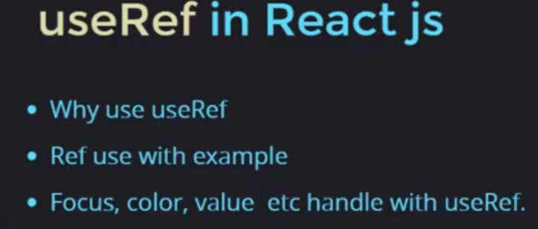

As we have used createRef (Ref) in class component to manipulate DOM just to get functionality like focus , changing color or setting and getting values, similarly if we want to achieve the same thing in function component then we will have to use useRef Hook.

|  |
| --- |
| import React from "react";  function UseRefInFunctionalComponent(){      const inputRef=React.useRef(null);      function handleInput(){          inputRef.current.value="1000"          // inputRef.current.value.style.color="red"          inputRef.current.focus();      }      return(          <div>              <h1>This is useRef Hook in Function Component!!</h1>              <input type="text" ref={inputRef} />              <button onClick={()=>handleInput()}>update useRef Hook</button>          </div>      );  }export default UseRefInFunctionalComponent; |



In function component we can create Ref: [const inputRef=React.useRef(null); ]

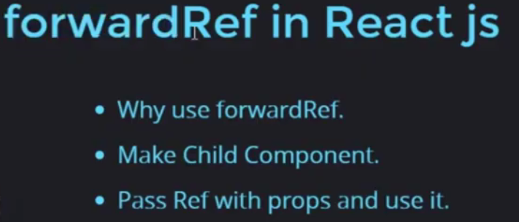

6.24.00

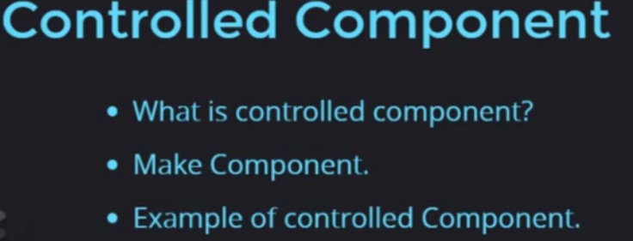

Basically in react js it is recommended to handle most of the thing using props and state this is called Controlled component.

In case of Java script of jquery whenever we want to handle the form’s elements like input type then we used to handle using doucument.getElementById or by id of the element. This kind of the form handling is called un-controlled component.

|  |
| --- |
| import React from "react";  function UseRefInFunctionalComponent(){      const inputRef=React.useRef(null);      let [inputVal, setInputVal]=React.useState("100");      function handleInput(){          inputRef.current.value="1000"          // inputRef.current.value.style.color="red"          inputRef.current.focus();      }      return(          <div>              <h1>This is useRef Hook in Function Component!!</h1>              Fixed Value : <input type="text" ref={inputRef}  value={1000} /> <br />              UseState Fixed Val: <input type="text" ref={inputRef}  value={inputVal} /> <br />              Edit Value using setInputVal: <input type="text" ref={inputRef}  value={inputVal} onChange={()=>setInputVal()} />              <button onClick={()=>handleInput()}>update useRef Hook</button>          </div>      );  }export default UseRefInFunctionalComponent; |

Output:

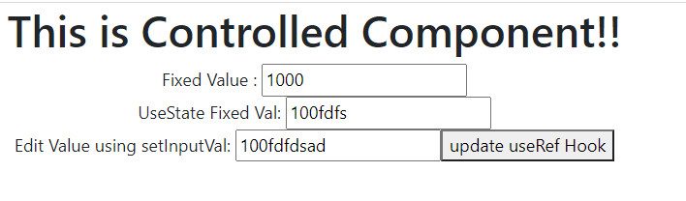

So here we can control the input box using useState.

**UnControlled Component:**

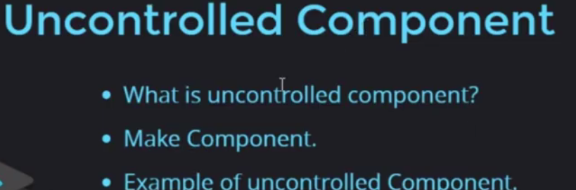

Example using useRef for uncontrolled component:

**Simple HOC:**



When a component is passed as porps and in result we get a different component then it is called High Order Component.

6.50.00

Example to written and mention here.

**Routing Setup:**





7:08:00



7:19:00

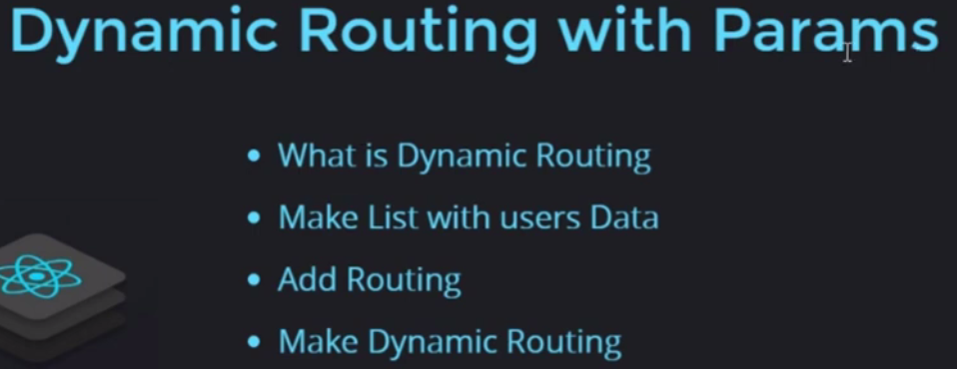

7:28

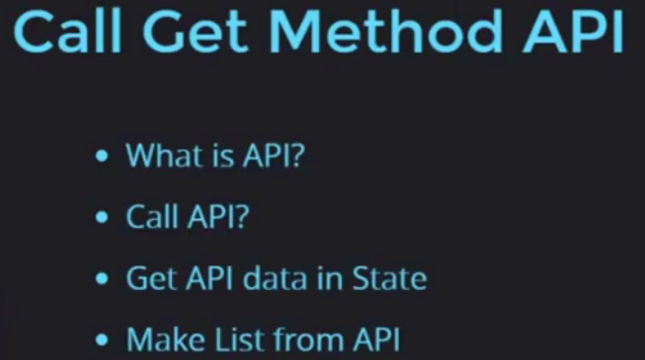

7:40:00

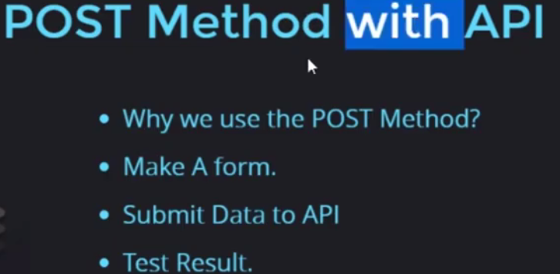

8:00:00

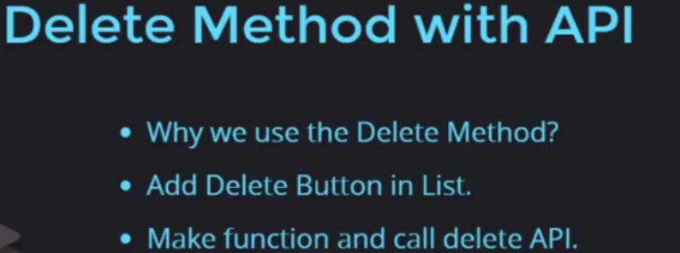

8:18:30

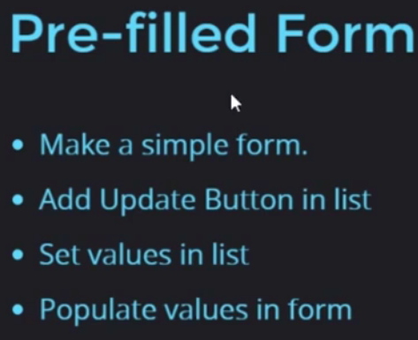

8:28:28



8:36:38



8:47:17



8:59:48